

**Names :**

**Supervisor** : Dr Amal Mahmoud

student project :

* 1- Bishoy victor Nabil
* 2- Ayman saadan Alkot
* 3-Ebram Effat Abdullah
* 4-Amgad Abdelhamid Hamza
* 5-Bassem

Abstract

The "Job Scope" project explores compensation trends and job market characteristics within the Egyptian technology sector. Utilizing data scraped from a job listing website, this analysis aims to uncover critical insights into salary distributions, job roles, business focus, and diversity across the tech industry. By examining various factors like years of experience, education level, and company location, the project provides a comprehensive view of compensation dynamics and market needs. The results are intended to guide job seekers, employers, and policymakers in making informed decisions regarding employment and compensation in Egypt's tech industry.

Introduction

The technology sector in Egypt has been experiencing significant growth, with increasing demand for skilled professionals across various roles. As the job market evolves, understanding compensation trends and the factors influencing salaries becomes crucial for job seekers, employers, and decision-makers. The "Job Scope" project was initiated to provide a data-driven analysis of compensation and job roles in the Egyptian technology sector, leveraging data scraped from a popular job website.

This project aims to address several key questions, such as:

* What is the average compensation across different business markets, job roles, and locations?
* Are there disparities in compensation based on experience, education, or gender?
* How does the work setting (remote, hybrid, in-office) impact compensation and job availability?

By answering these questions, the project offers valuable insights that will help both individuals and organizations navigate the evolving job market landscape.

Methodology

***Data Description***

The dataset used in this analysis was scraped from a website that lists technology sector jobs in Egypt. It contains information about job titles, business markets, years of experience (YOE), education requirements, compensation (total and ranges), and company locations. Additional variables include work settings (remote, hybrid, or in-office), gender representation, and business focus (e.g., software, finance).

The dataset's key columns that were scraped include:

* **Timestamp**
* **Job title**
* **Degree**
* **Business market**
* **Programming language**
* **Business focus**
* **Business line**
* **Industries**
* **Is egp**
* **Years of experience (YOE)**
* **Total compensation in EGP**
* **Work setting (remote, hybrid, in-office)**
* **Company location**
* **Gender**
* **Degree requirement**

**Before dividing the table into 7 tables(no.of columns is 1650):**

* **Table 1: job**

**- job_id**

**- Company_ID**

* **Title**
* **MinCompensationRange**
* **MaxCompensationRange**
* **WorkSetting**
* **Yoe**
* **TotalCompensationEgp**
* **IsEgp**

* **Table 2: Calendar**

**- date**

* **Year**
* **Quarter**
* **MonthName**
* **MonthNum**
* **Weekday**
* **Weeknum**

* **Table 3 : Company**
* **Company_Id**
* **Businessmarket**
* **BusinessSize**
* **BusinessFocus**
* **Businessline**
* **Location**

* **Table 4 : Industries**
* **ID_In**
* **Industry**

* **Table 5 : Programming Language**
* **ID_pL**
* **Programming Language**

* **Table 6 : Employee**
* **Emp_ID**
* **Gender**
* **Level**
* **Degree**

* **Table 7 : Data**
* **Timestamp**
* **ID**
* **ID_Employee**
* **ID_job**

*Tools*

The following tools were used to perform the analysis:

* **Excel**: Initial data cleaning, preprocessing, and organization of the scraped data.
* **Python**: Advanced data manipulation, outlier detection, and statistical analysis.
* **SQL**: For querying, filtering, and joining data from different sources during the analysi
* **Tableau**: For visualizing key insights and creating dashboards to represent trends in compensation, job roles, and market characteristics.

***Method***

1. **Data Collection and Preprocessing**: The data was scraped from the website using automated scraping scripts. The collected data was first cleaned in Excel, where missing values and duplicates were handled, and categorical variables were encoded.
2. **Exploratory Data Analysis (EDA)**: Python was used to conduct EDA, where key variables like compensation, job titles, business size, and location were analyzed. Outliers in salary data were identified and handled to prevent skewed results.
3. **Statistical Analysis**: Python and SQL were employed to calculate averages, medians, and standard deviations of compensation based on factors like YOE, education, and location. This analysis helped identify patterns in compensation distribution.
4. **Visualization**: Tableau was used to create interactive dashboards that visualize compensation trends, gender pay gaps, job role distribution, and work setting preferences across different industries and company sizes.

Contribution

The "Job Scope" project offers several key contributions to understanding the Egyptian technology job market:

1. **Compensation Insights**: The project reveals average compensation by business market, industry, job title, and work setting, helping professionals assess their market value.
2. **Job Role Distribution**: By analyzing common job roles and their relationship with business focus, the project highlights the most in-demand roles and programming languages in the tech sector.
3. **Diversity and Inclusion**: The analysis uncovers gender pay disparities and representation issues, providing actionable insights for improving diversity in the industry.
4. **Work Setting Trends**: The project explores how work settings (remote, hybrid, in-office) influence compensation and job availability, shedding light on the evolving preferences of companies and employees in the tech sector.
5. **Geographical Analysis**: By comparing compensation across regions, the project identifies high-paying areas and provides insights into regional differences in job market dynamics.

**Appendix**

The appendix contains:

* **Data Source**: A detailed description of the website from which the data was scraped, along with a summary of the scraping process.
* **Code Snippets**: Examples of Python, SQL queries, and Tableau dashboards used in the analysis.
* **Glossary of Terms**: Definitions for terms such as "business market," "YOE," and "business focus" to clarify the scope of analysis.
* **Limitations**: Discussion of any limitations faced during data collection and analysis, such as missing values or the scope of the dataset.

**Cleaning**

1-The image shows a Python script that imports several libraries for data analysis and visualization, reads a CSV file containing salary data, and prepares for further data exploration.

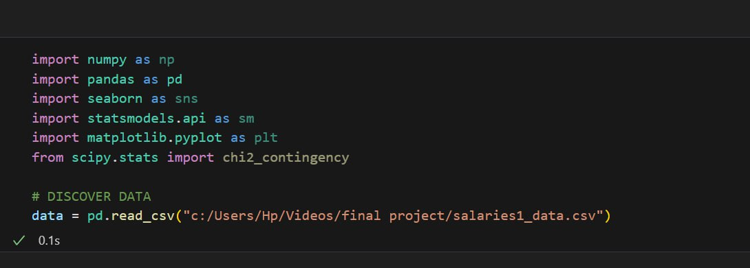

2-The image displays the output of data.info() from a Pandas DataFrame, revealing that it contains 1,649 entries and 18 columns, with various data types, including objects and floats, while noting some columns have missing values.

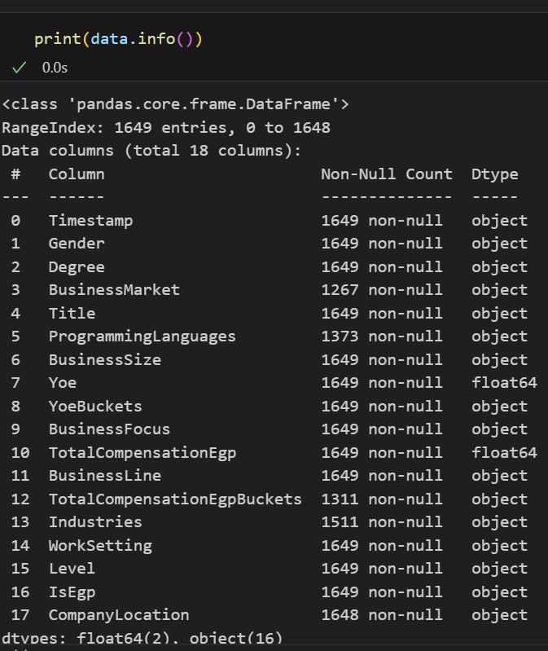

3-The image displays the output of data.info() from a Pandas DataFrame, revealing that it contains 1,649 entries and 18 columns, with various data types, including objects and floats, while noting some columns have missing values.

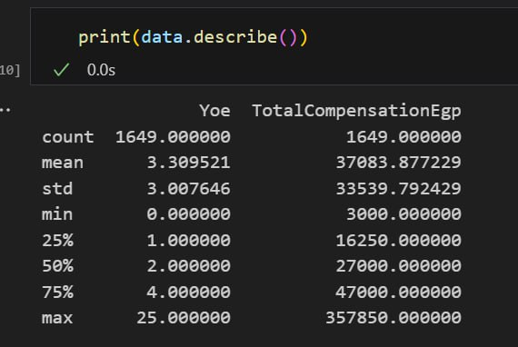

4-The code snippet print(data.duplicated().sum()) outputs the total number of duplicate rows in the DataFrame data

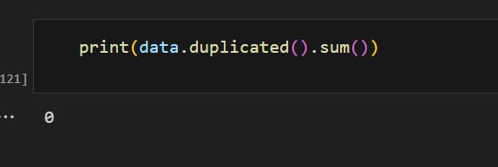

5-The code snippet print(data.isnull().sum()) outputs the number of missing values for each column in the DataFrame data.

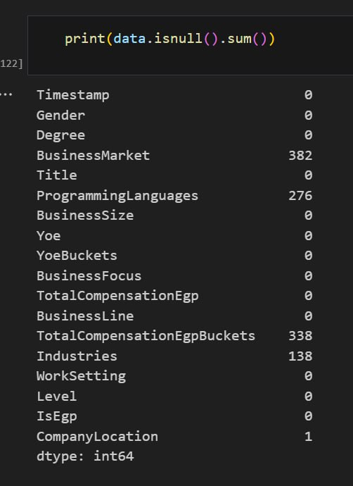

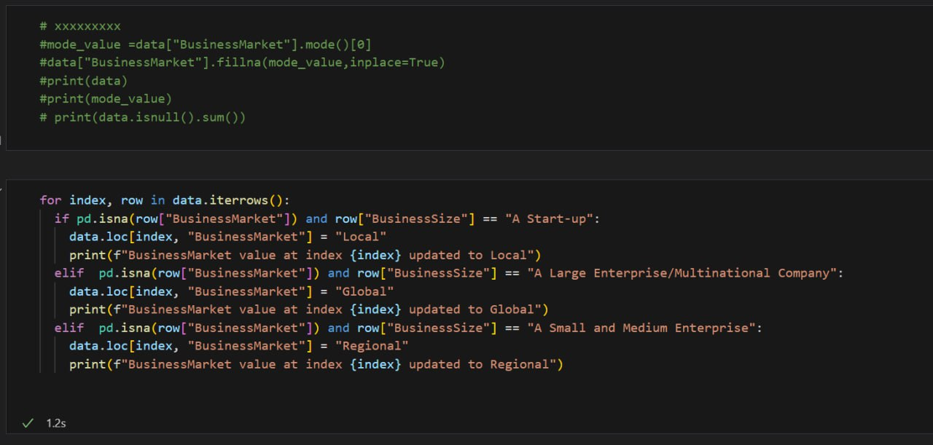

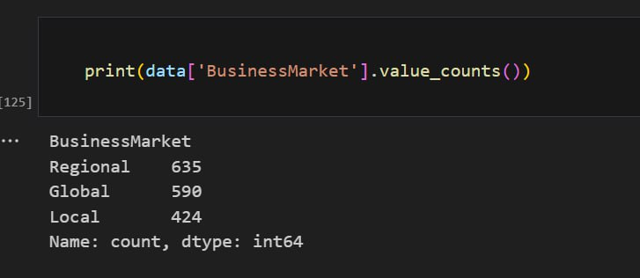

7-The code snippet iterates through a DataFrame, and for each row with missing "Programming Languages" data, it assigns a specific set of programming languages based on the job title, assuming the current location is Egypt

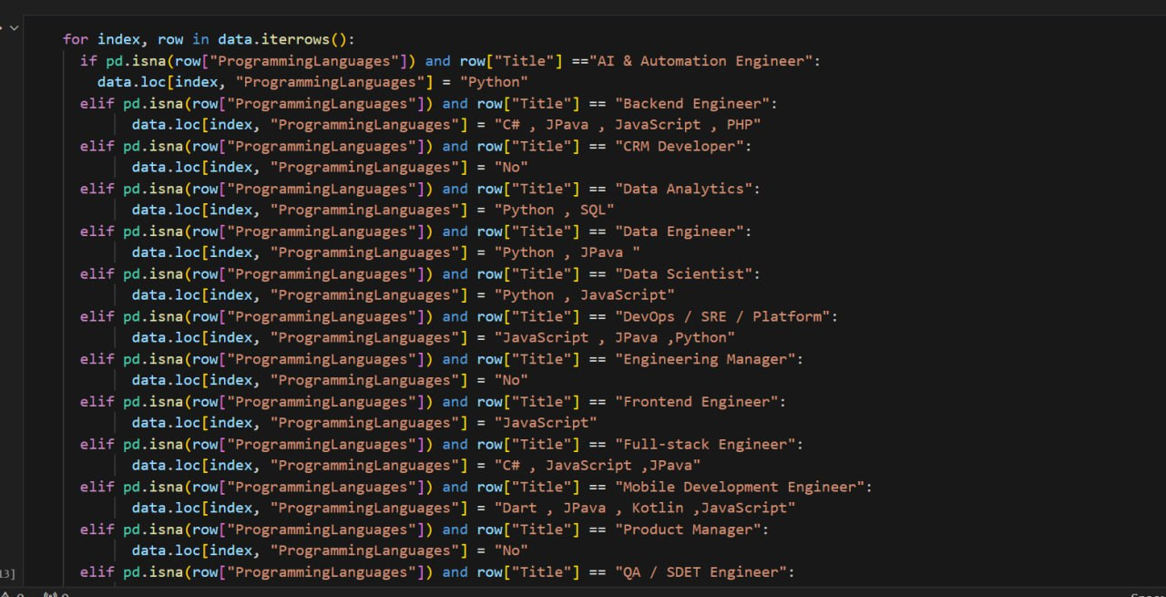

8-The code snippet splits a column named "TotalCompensationEgpBuckets" into two new columns, "MinCompensationRange" and "MaxCompensationRange", based on the hyphen separator. It then removes the "K" suffix from the "MaxCompensationRange" column and drops the original "TotalCompensationEgpBuckets" column.

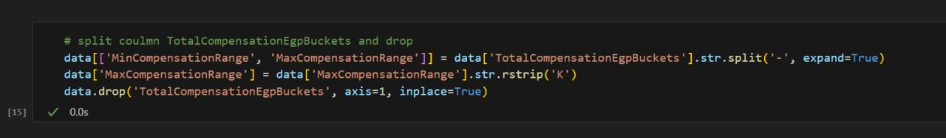

9- The code snippet first converts a column named "Timestamp" to a datetime format, then removes the time component, and finally converts it back to a datetime format with only the date. It also fills missing values in the "Company Location" column with "Cairo".

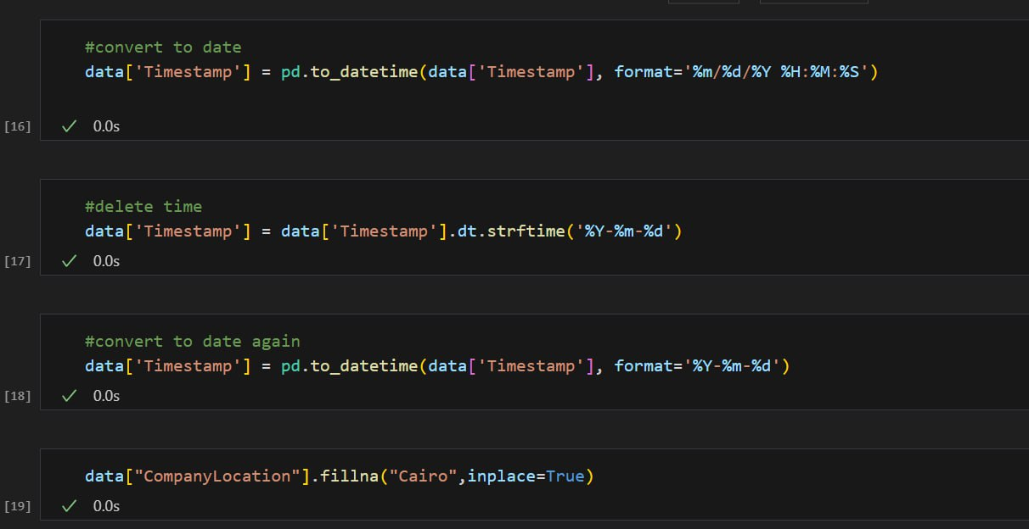

10-The code snippet iterates through a DataFrame and fills in missing values for "MinCompensationRange" and "MaxCompensationRange" based on the value of "TotalCompensationEgp" and predefined ranges

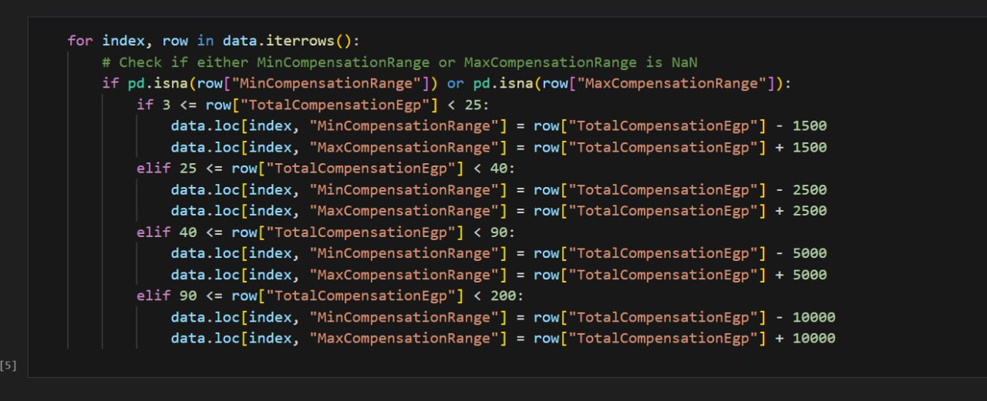

11-The code snippet converts the "MaxCompensationRange" and "MinCompensationRange" columns to numeric data types and multiplies them by 1000, then drops the "YoeBuckets" column from the DataFrame

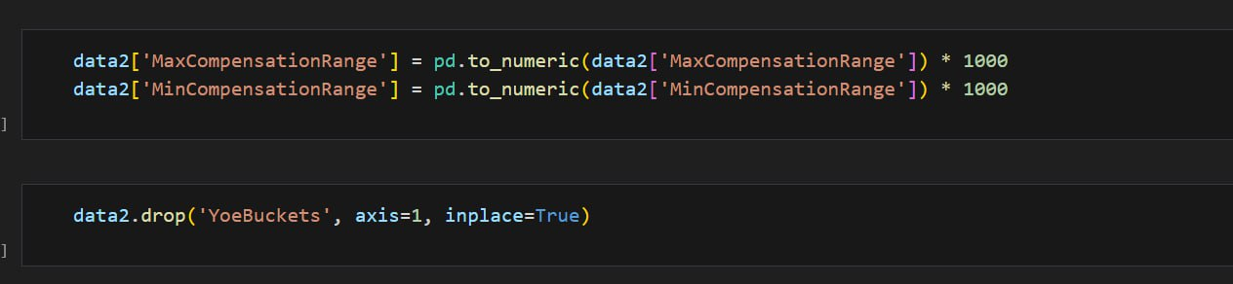

12-The code snippet handles missing values in a dataset by imputing categorical columns using the most frequent value and numerical columns using KNN imputation, then encodes the categorical column "Industries" and finally converts the imputed data back to a DataFrame with restored labels

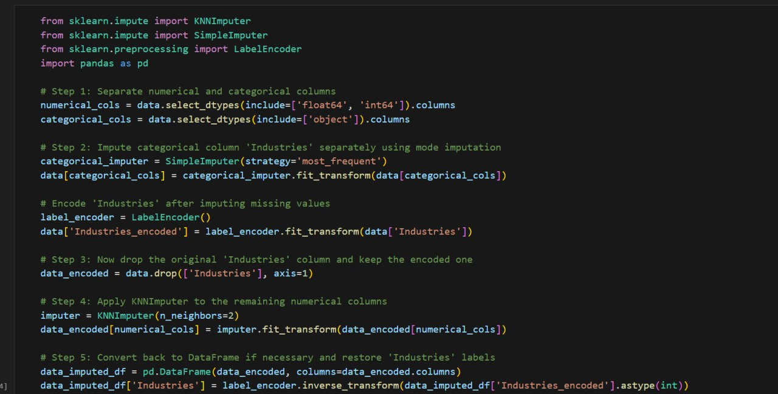

13-The code snippet creates dummy variables for categorical columns, handles missing values, converts boolean columns to numeric, defines independent and dependent variables, and fits a regression model using statsmodels.

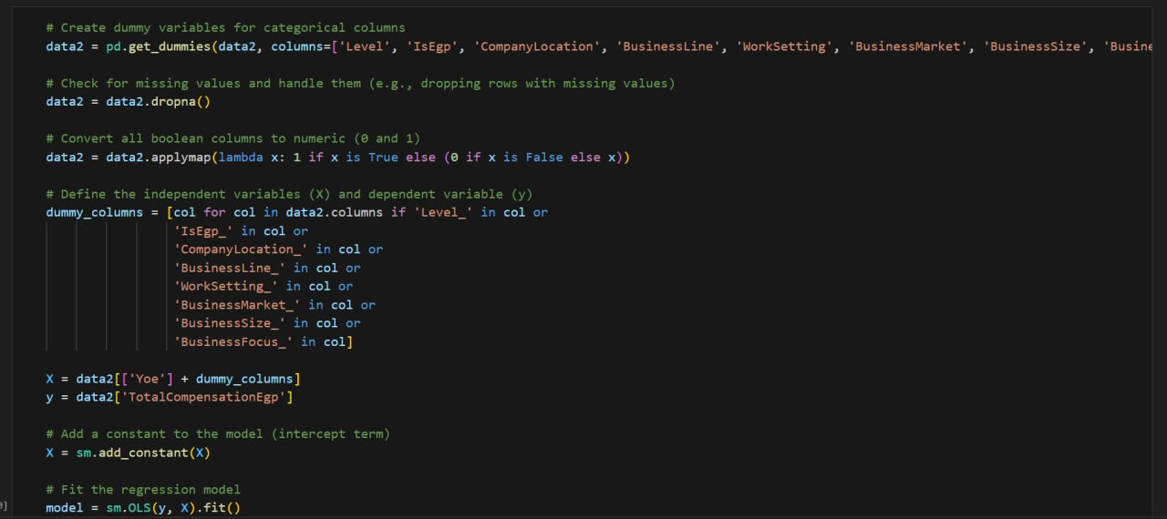

**Analysis**

1-The code snippet creates a box plot of the "TotalCompensationEgp" column from the data2 DataFrame, with a figure size of 6x4, a title of "TotalCompensationEgp", and y-label of "TotalCompensationEgp Rate"

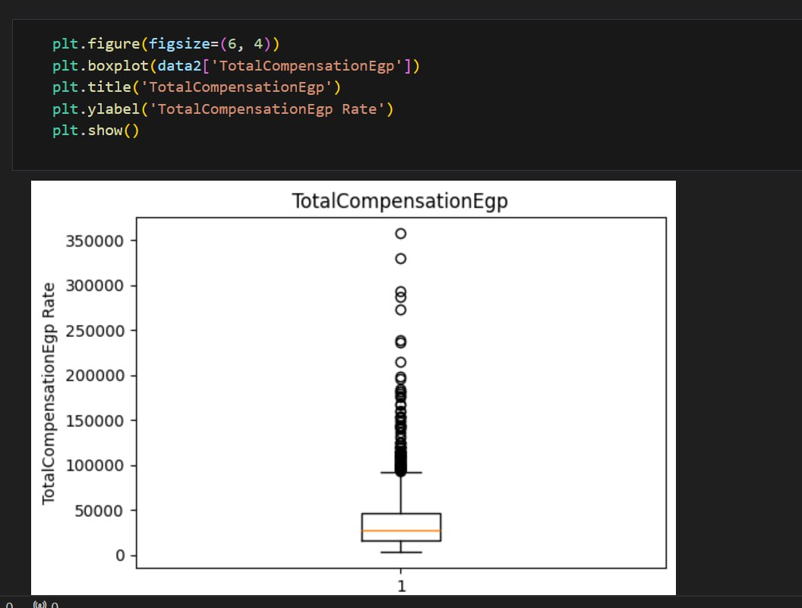

2-The code snippet calculates the first quartile (Q1), third quartile (Q3), interquartile range (IQR), lower bound, and upper bound of the "TotalCompensationEgp" column in the data2 DataFrame, and then identifies outliers using these values.

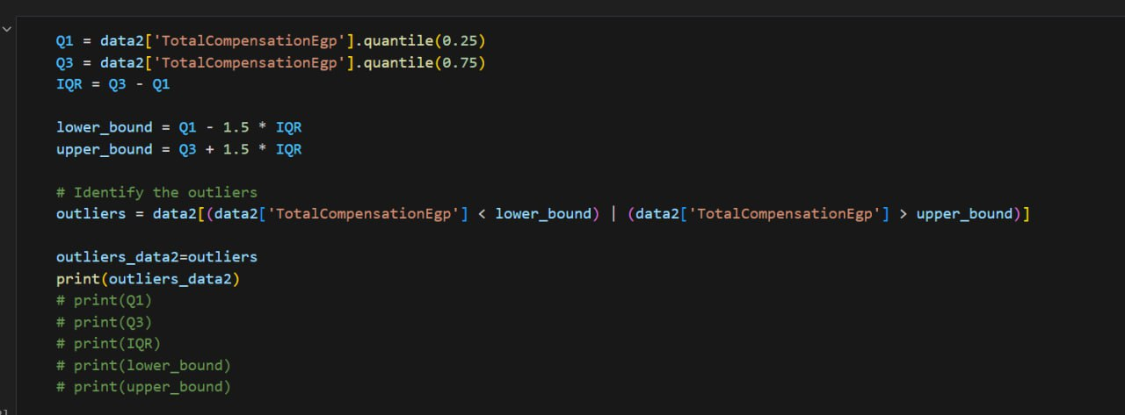

3-The code snippet creates a pivot table using the "BusinessSize" and "BusinessMarket" columns as index and calculates the mean of the "TotalCompensationEgp" column. It then fills missing values with 0, prints the pivot table, sets the style to "whitegrid", creates a color palette, creates a figure with a size of 14x8, unstacks the pivot table, creates a bar plot using the unstacked pivot table with specified parameters, and labels the bars with the mean values.

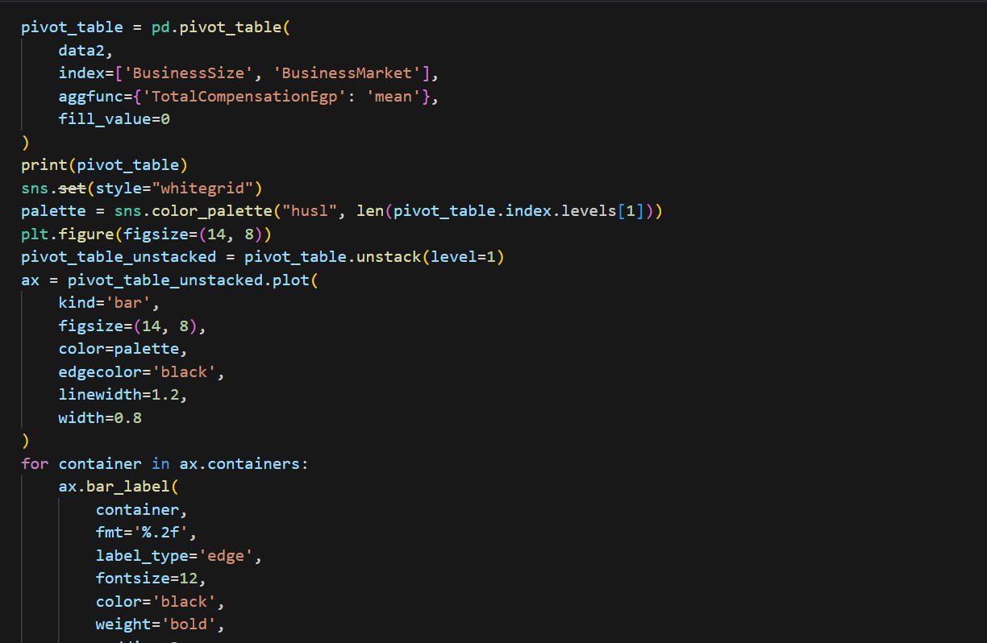

4-The code snippet creates a pivot table using the "Level" column as index and calculates the size of each level, fills missing values with 0, prints the pivot table, creates a bar plot with specified parameters, and sets the title, x-label, y-label, and rotation of x-ticks.

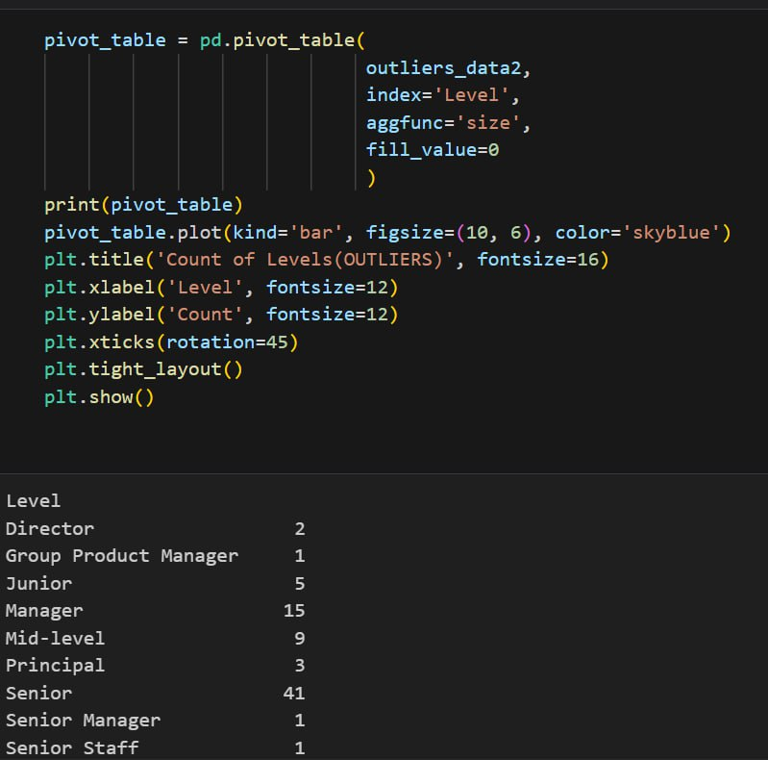

5-The code snippet creates a pivot table using the "BusinessMarket" column as index and calculates the mean of the "TotalCompensationEgp" column and the count of the "Gender" column. It then calculates the percentage of each business market's total compensation, prints the pivot table, creates a bar plot with specified parameters, adds labels for the bars with the percentage values, and sets the title, x-label, and y-label.

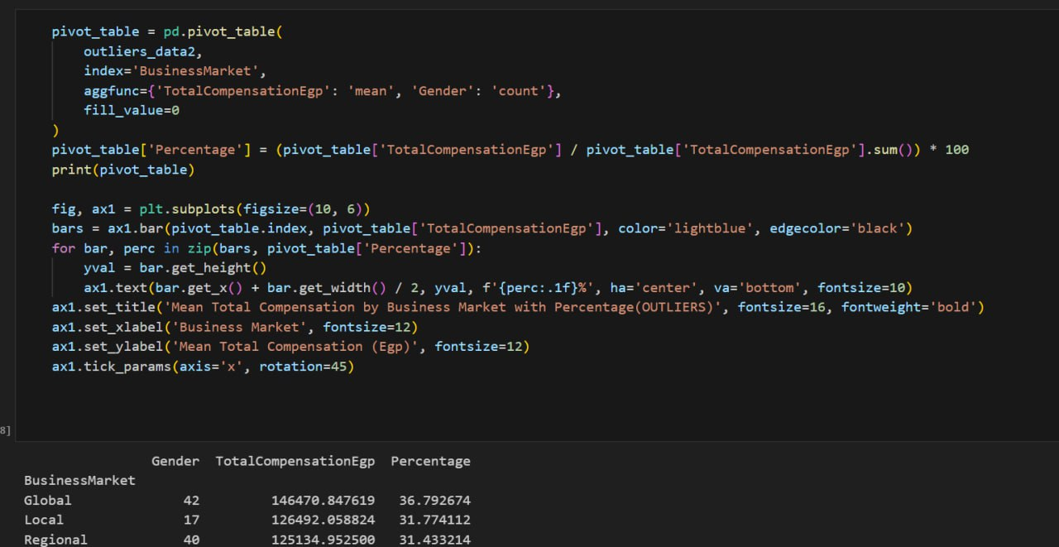

6-The code snippet creates a pivot table using the "IsEgp" column as index and calculates the size of each level, fills missing values with 0, prints the pivot table, creates a pie chart with specified parameters, sets the title, and shows the plot.

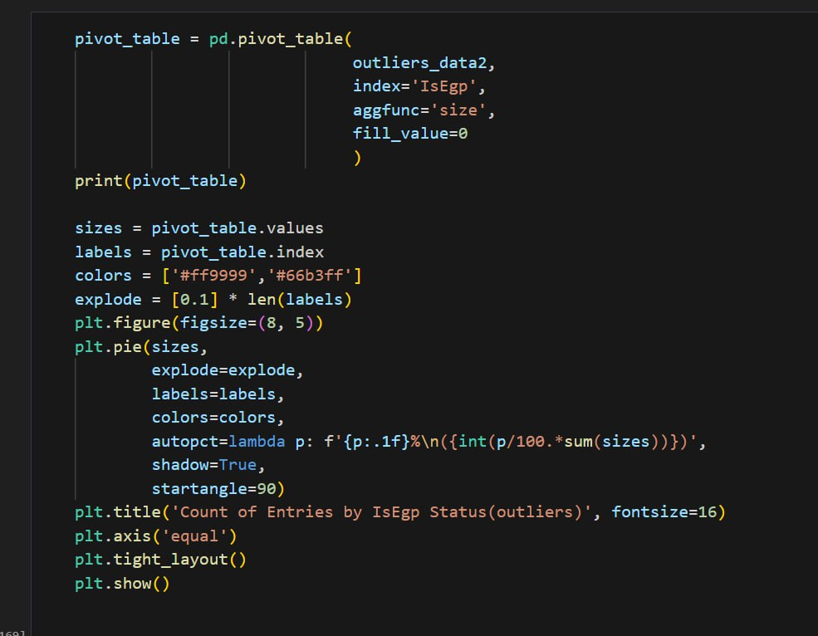

7-The code snippet imports necessary libraries, defines a list of categorical columns, checks for existing columns in the data, and then iterates through each existing categorical column to perform ANOVA analysis on the "TotalCompensationEgp" column, printing the ANOVA table if successful or an error message if not.

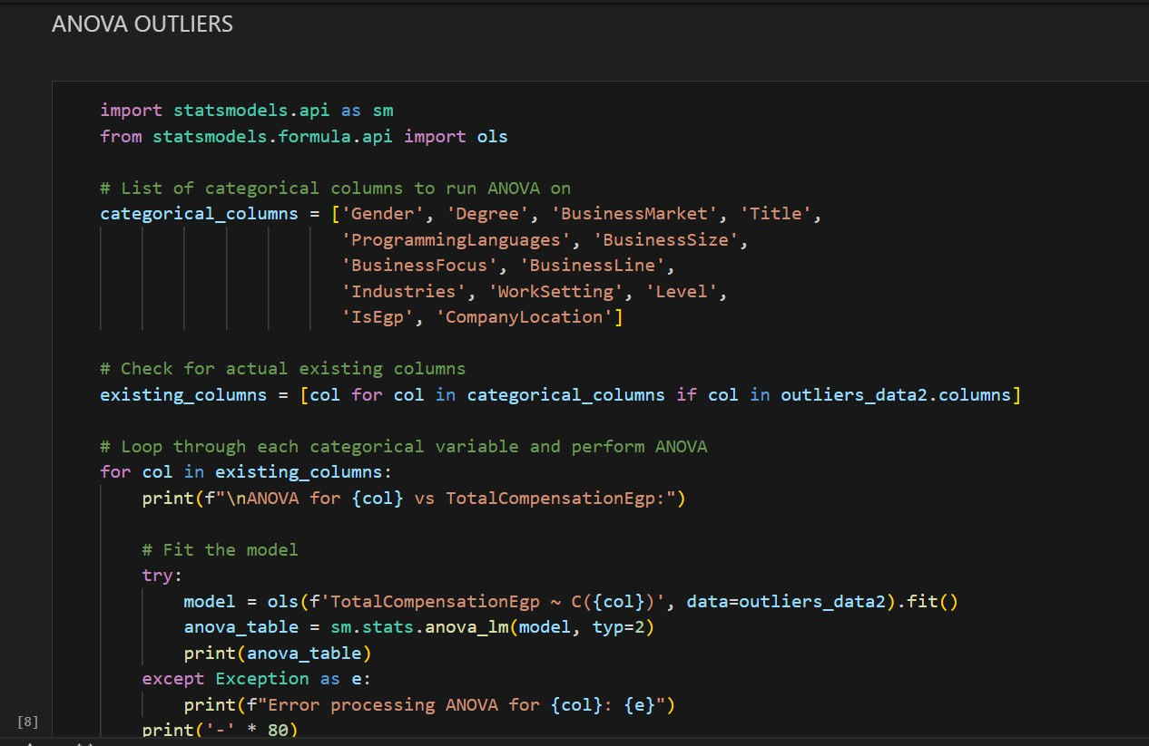

8-The code snippet filters the data2 DataFrame to include only rows where the "Level" is "Junior", "Mid-level", or "Senior", creates a pivot table using the "Level" column as index and calculates the size of each level, fills missing values with 0, prints the pivot table, creates a pie chart with specified parameters, sets the title, and shows the plot

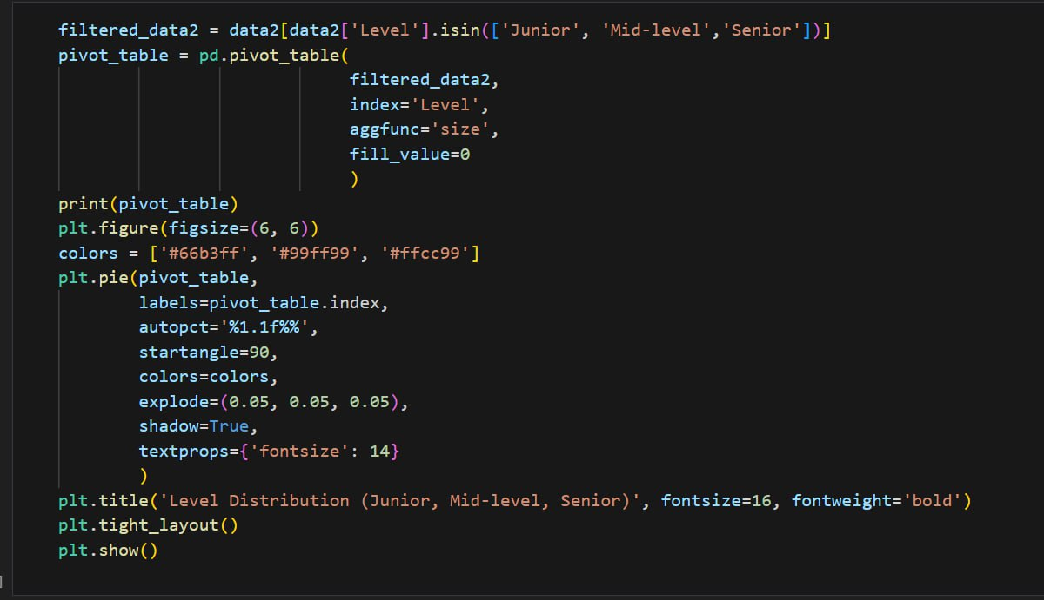

9-The code snippet filters the data2 DataFrame to include only rows where the "Level" is "Junior", "Mid-level", or "Senior", creates a pivot table using the "Level" and "BusinessSize" columns, calculates the size of each level, fills missing values with 0, prints the pivot table, sets the style to "whitegrid", creates a color palette, creates a figure with a size of 12x7, creates a stacked bar plot using the pivot table with specified parameters, and labels the bars with the counts

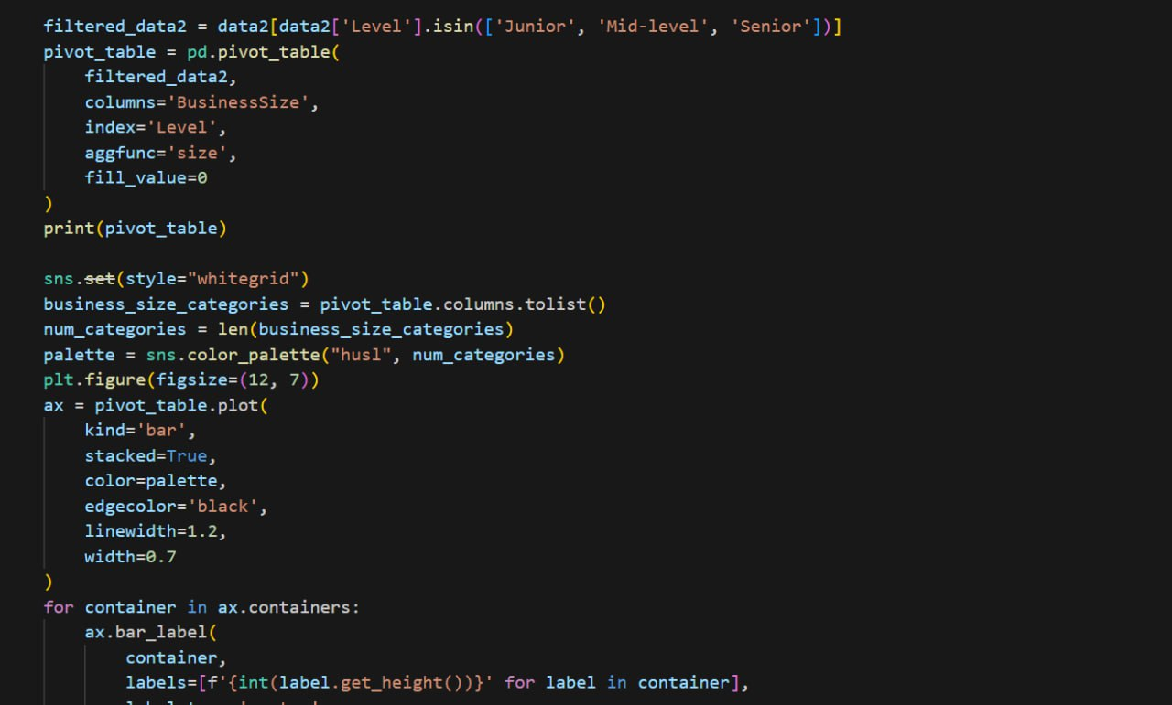

10-The code snippet creates a pivot table using the "Degree" column as index and calculates the size of each level, fills missing values with 0, prints the pivot table, creates a pie chart with specified parameters, sets the title, and shows the plot.

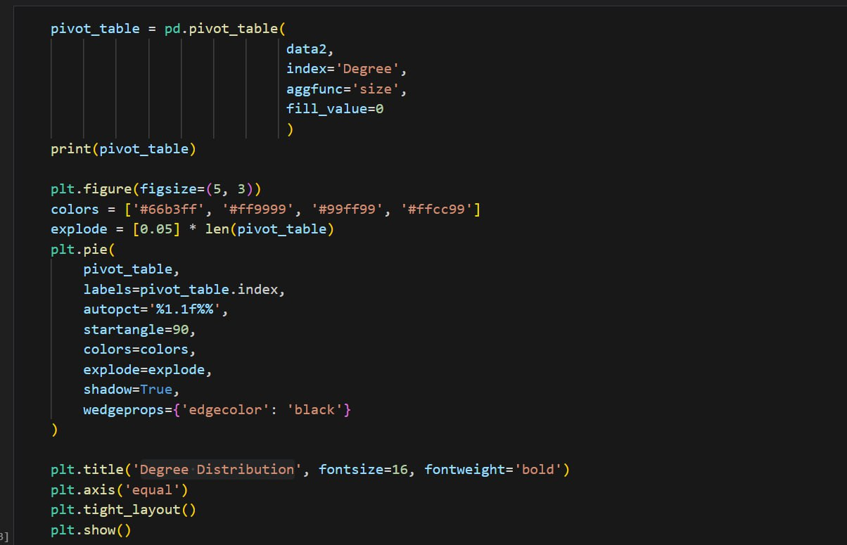

11-The code snippet filters the data2 DataFrame to include only rows where the "Degree" is "No", creates a pivot table using the "BusinessSize" and "Degree" columns, calculates the size of each level, fills missing values with 0, prints the pivot table, creates a bar plot with specified parameters, sets the title, x-label, y-label, rotation of x-ticks, legend, and labels the bars, and finally shows the plot

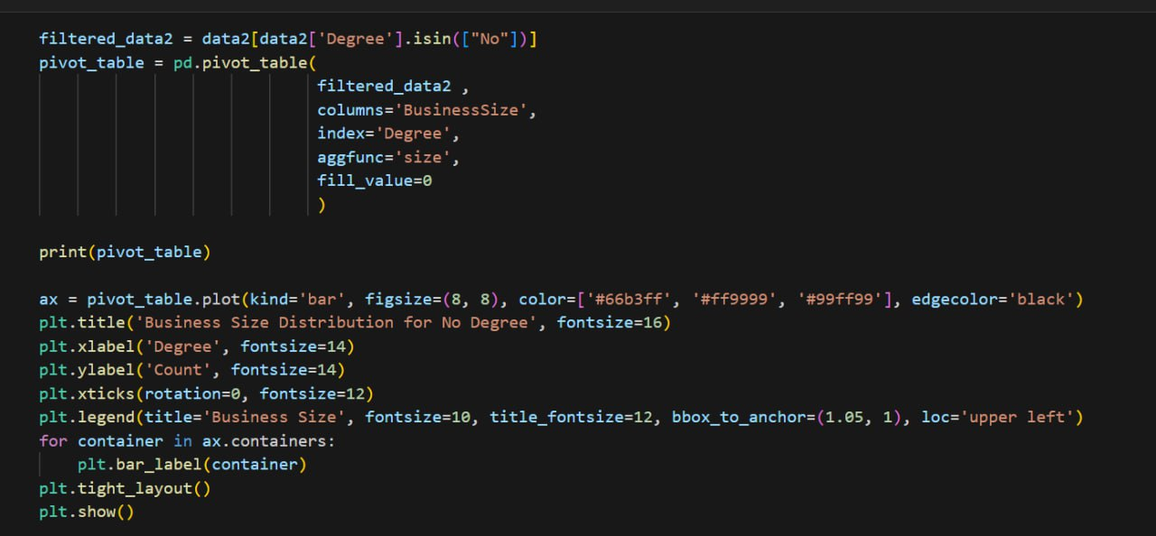

12-The code snippet filters the data2 DataFrame to include only rows where the "Degree" is not "No", creates a pivot table using the "Level" and "Degree" columns, calculates the size of each level, fills missing values with 0, prints the pivot table, creates a bar plot with specified parameters, sets the title, x-label, y-label, rotation of x-ticks, legend, and labels the bars, and finally shows the plot.

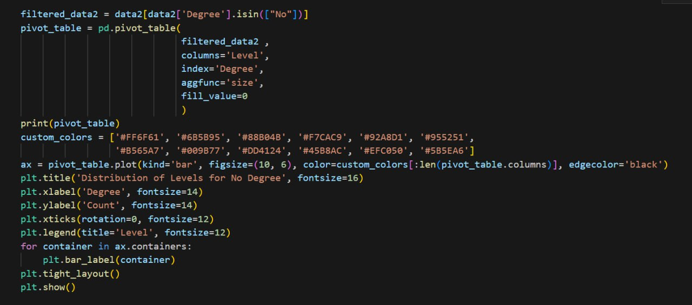

13-The code snippet creates a pivot table using the "BusinessLine" column as index and the "BusinessSize" column as columns, calculates the size of each level, fills missing values with 0, prints the pivot table, creates a stacked bar plot with specified parameters, sets the title, x-label, y-label, rotation of x-ticks, legend, and labels the bars, and finally shows the plot.  
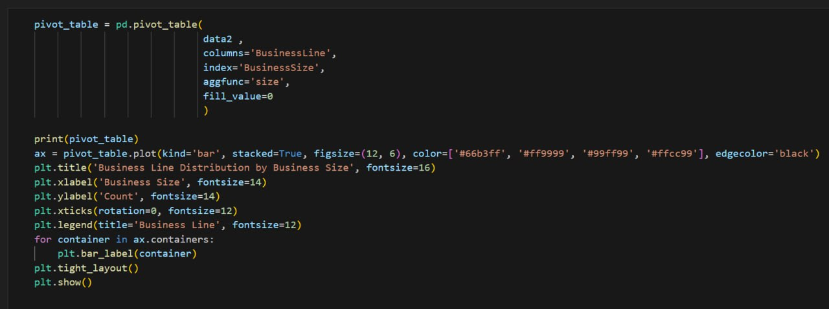

14-The code snippet creates a pie chart to visualize the gender distribution in the dataset

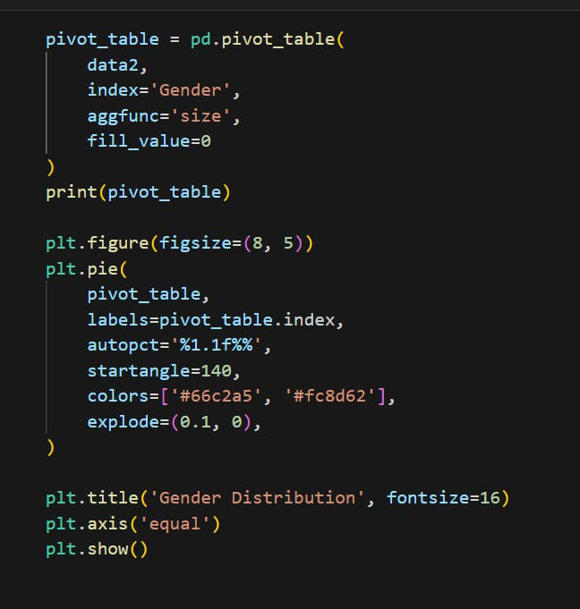

15-The code snippet filters the data2 DataFrame to include only female rows, creates a pivot table using the "BusinessSize" and "BusinessMarket" columns as index and calculates the size of each level, fills missing values with 0, prints the pivot table, creates a stacked bar plot with specified parameters, sets the title, x-label, y-label, adds labels for the bars with the counts, and shows the plot.

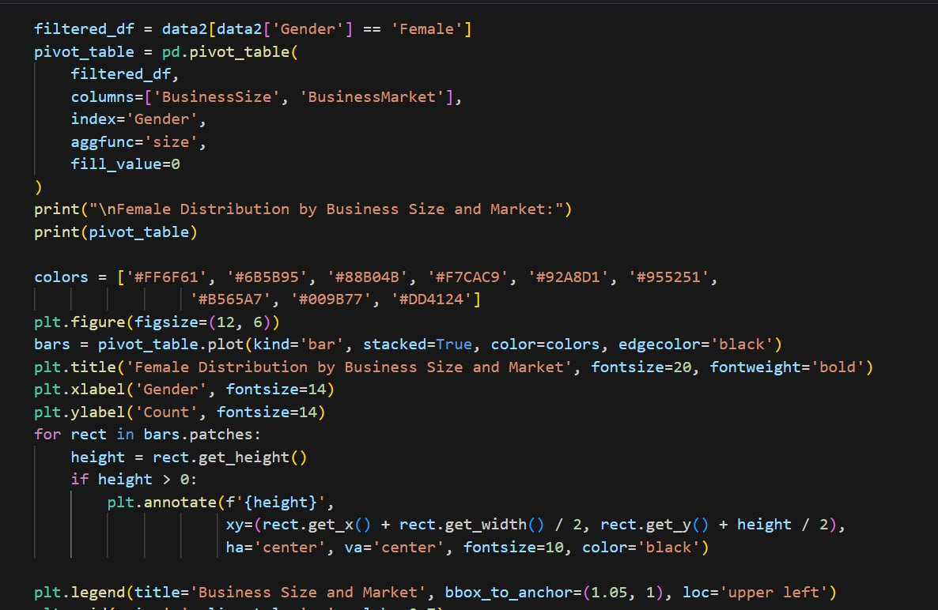

16-The code snippet creates a pivot table using the "BusinessSize" column as index and calculates the mean of the "TotalCompensationEgp" column, fills missing values with 0, prints the pivot table, creates a bar plot with specified parameters, sets the title, x-label, y-label, rotation of x-ticks, adds labels for the bars with the counts, adds a grid to the y-axis, and shows the plot.

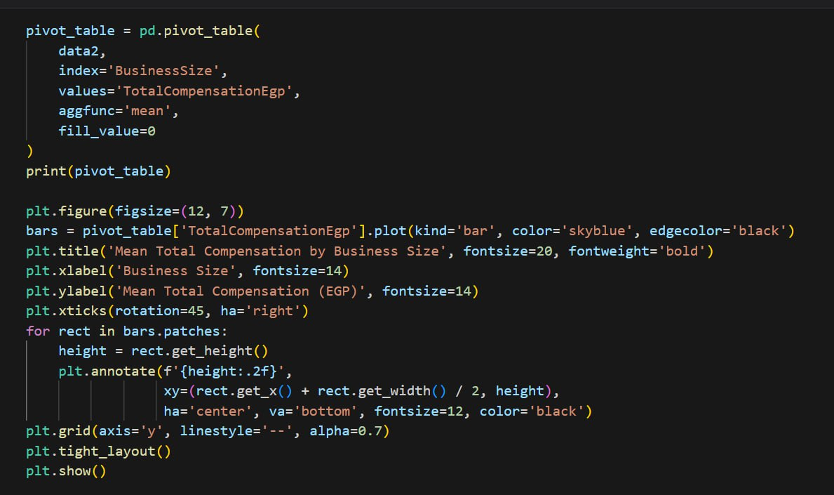

17-The code snippet creates a pivot table using the "Company Location" column as index and calculates the count of the "TotalCompensationEgp" column, fills missing values with 0, finds the top 5 locations by count, prints the top 5, creates a bar plot with specified parameters, sets the title, x-label, y-label, rotation of x-ticks, adds labels for the bars with the counts, adds a grid to the y-axis, and shows the plot.

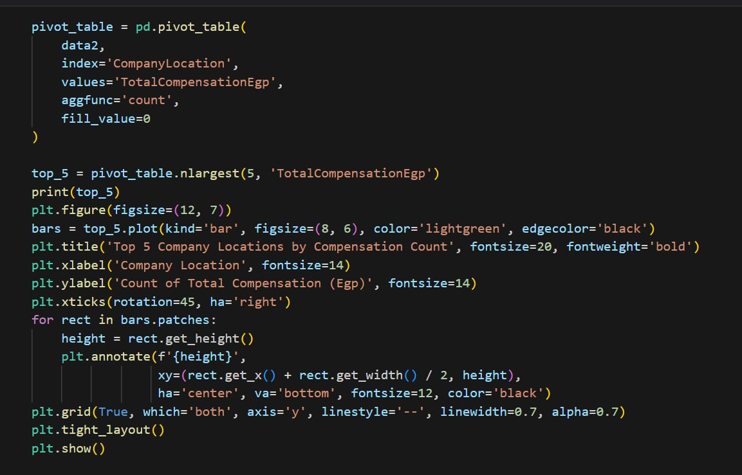

18-The code snippet creates a pivot table using the "Level" column as index and calculates the mean of the "TotalCompensationEgp" column, fills missing values with 0, prints the pivot table, creates a bar plot with specified parameters, sets the title, x-label, y-label, rotation of x-ticks, adds labels for the bars with the counts, adds a grid to the y-axis, and shows the plot

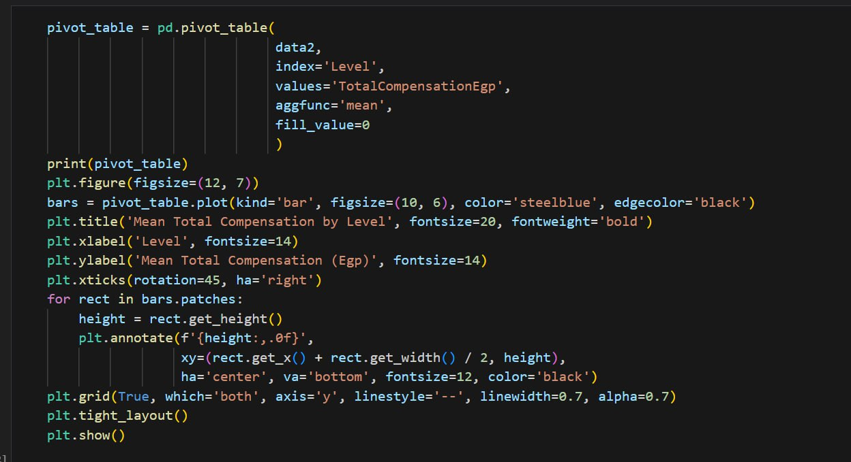

19-The code snippet checks the names of the sheets in a dictionary called all_sheets, prints the sheet names, and merges the 'Main Data' sheet with the 'Date', 'Industries', and 'Programming Languages' sheets using inner joins based on specified columns

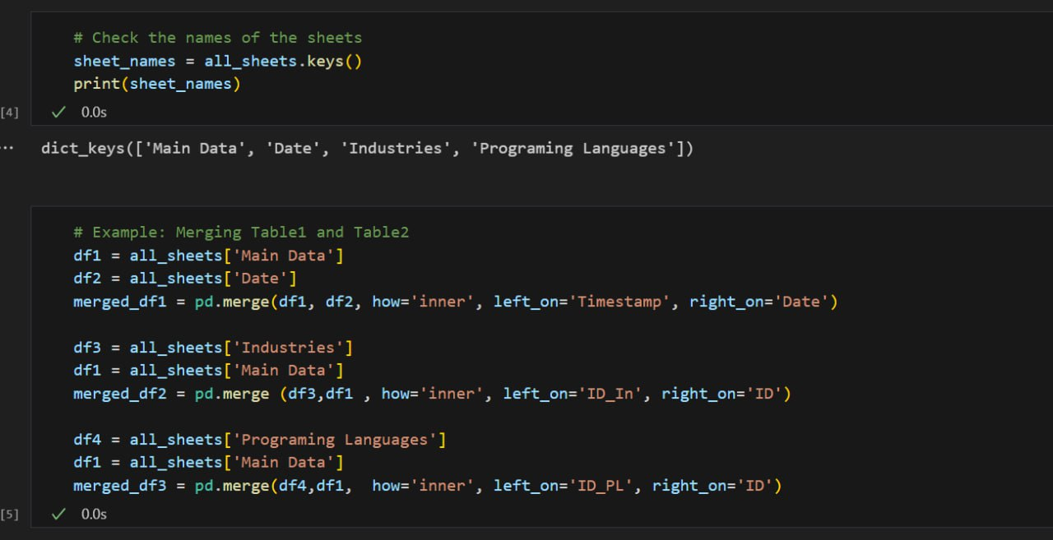

20-The code snippet creates a pivot table using the "Title" column as index and the "BusinessMarket" column as columns, calculates the size of each level, fills missing values with 0, finds the top 6 titles and top 6 business markets, prints the filtered pivot table, creates a bar plot with specified parameters, sets the title, x-label, y-label, rotation of x-ticks, legend, adds a grid to the y-axis, and shows the plot

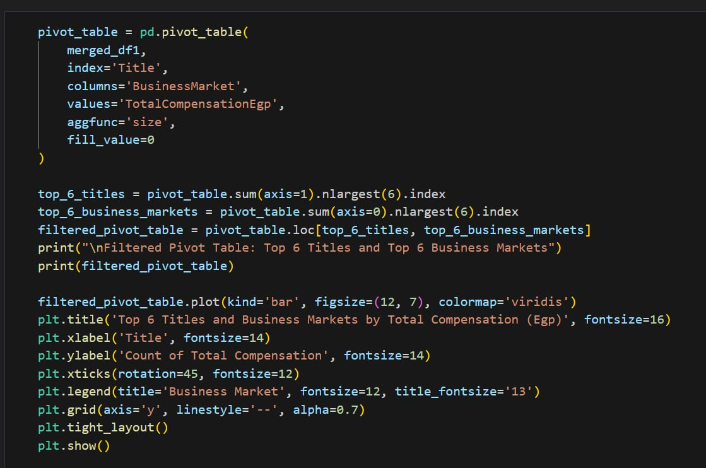

21-The code snippet filters the merged_df2 DataFrame to include only rows where the "Industries" column contains one of the specified industries, creates a pivot table using the "Industries" column as index and calculates the size of each level, fills missing values with 0, prints the pivot table, creates a bar plot with specified parameters, sets the title, x-label, y-label, rotation of x-ticks, adds labels for the bars with the counts, adds a grid to the y-axis, and shows the plot.

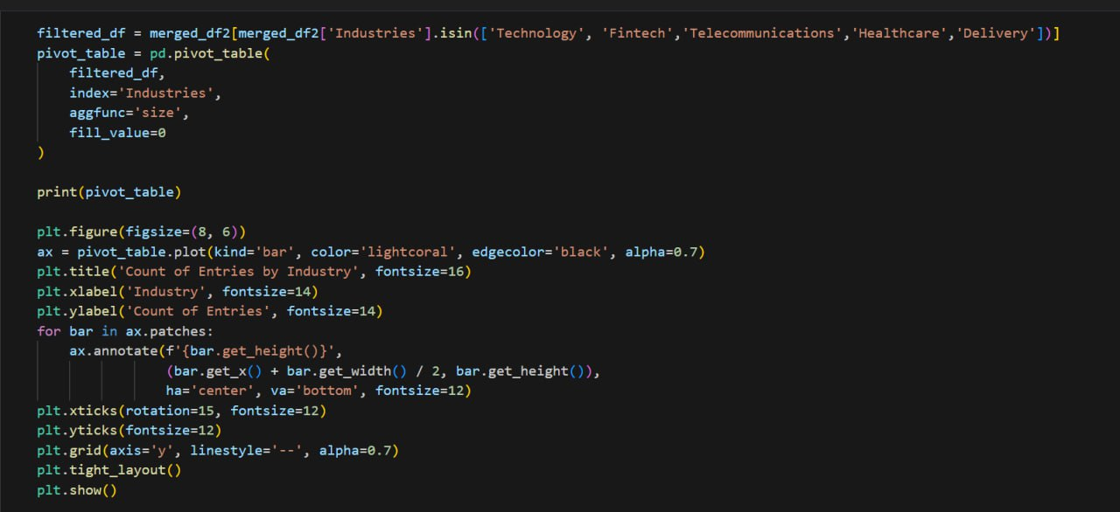

22-The code snippet filters the merged_df3 DataFrame to include only rows where the "Title" is one of the specified titles, creates a pivot table using the "Title" and "WorkSetting" columns as index and calculates the size of each level, fills missing values with 0, prints the pivot table, resets the index of the pivot table, creates a figure with a specified size, creates a stacked bar plot using the pivot table with specified parameters, sets the title, x-label, y-label, rotation of x-ticks, legend, adds a grid to the y-axis, and shows the plot

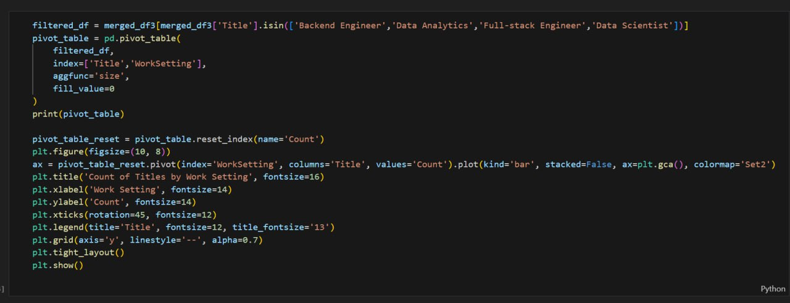

23-The code snippet creates a pivot table using the "WorkSetting" column as index and calculates the count of the "TotalCompensationEgp" column, adds a percentage column to the pivot table, prints the pivot table, creates a bar plot with specified parameters, sets the title, x-label, y-label, rotation of x-ticks, adds labels for the bars with the counts, adds a grid to the y-axis, and shows the plot

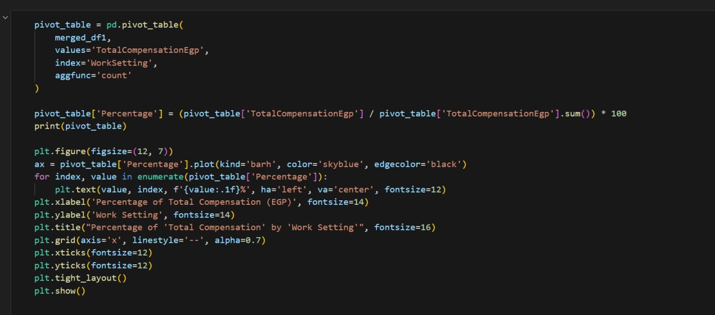

24-The code snippet creates a pivot table using the "WorkSetting" column as index and calculates the mean of the "TotalCompensationEgp" column, prints the pivot table, creates a bar plot with specified parameters, sets the title, x-label, y-label, rotation of x-ticks, adds a grid to the y-axis, and shows the plot

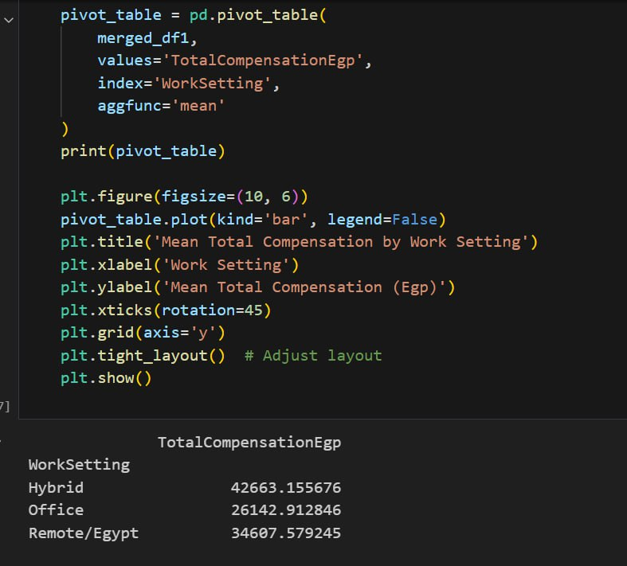

25-The code snippet filters the merged_df2 DataFrame to include only male rows with TotalCompensationEgp greater than 100000 and industries in Fintech or Technology, creates a pivot table using the "Industries" and "Gender" columns as index and calculates the size of each level, fills missing values with 0, prints the pivot table, creates a bar plot with specified parameters, sets the title, x-label, y-label, rotation of x-ticks, adds a grid to the y-axis, and shows the plot.

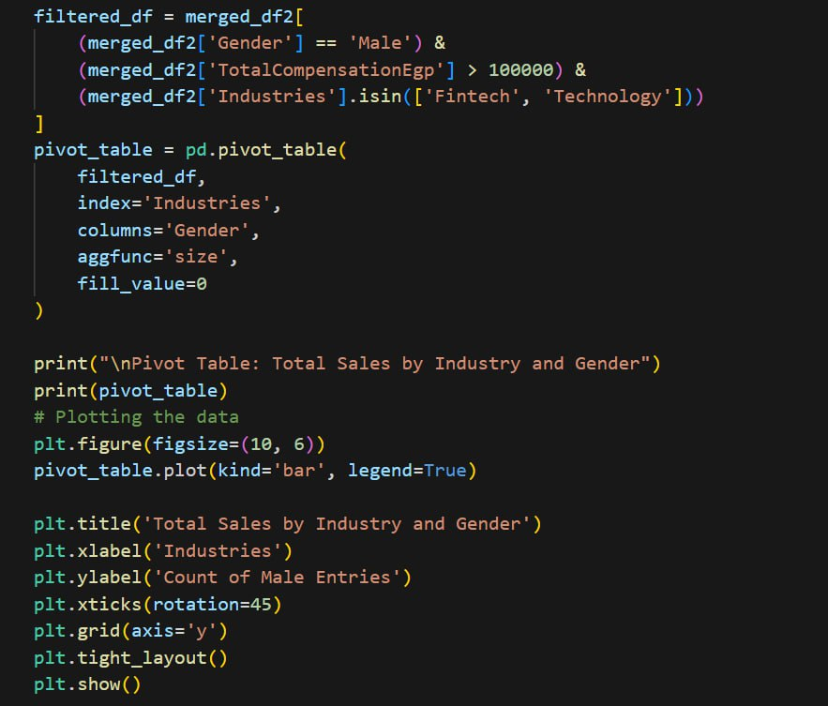

26-The code snippet creates a pivot table using the "Yoe" column as index and the "BusinessLine" column as columns, calculates the mean of the "TotalCompensationEgp" column, fills missing values with 0, and prints the pivot table

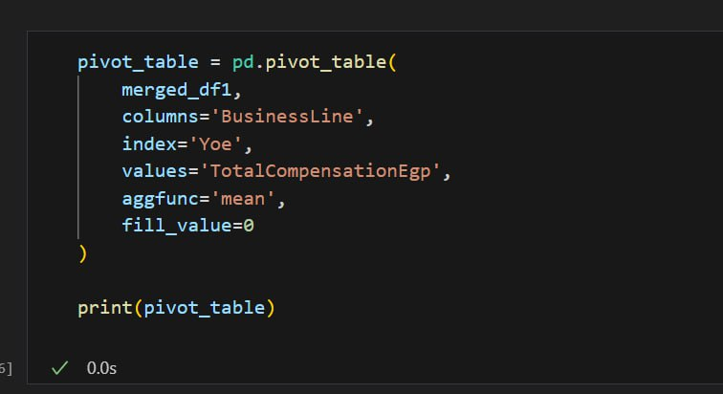

27-The code snippet creates a pivot table using the "Timestamp" column as index and the "BusinessMarket" column as columns, calculates the sum of the "Yoe" column, fills missing values with 0, prints the pivot table, filters the pivot table to the top 5 rows, creates a line plot with specified parameters, sets the title, x-label, y-label, rotation of x-ticks, legend, adds a grid to the y-axis, and shows the plot.

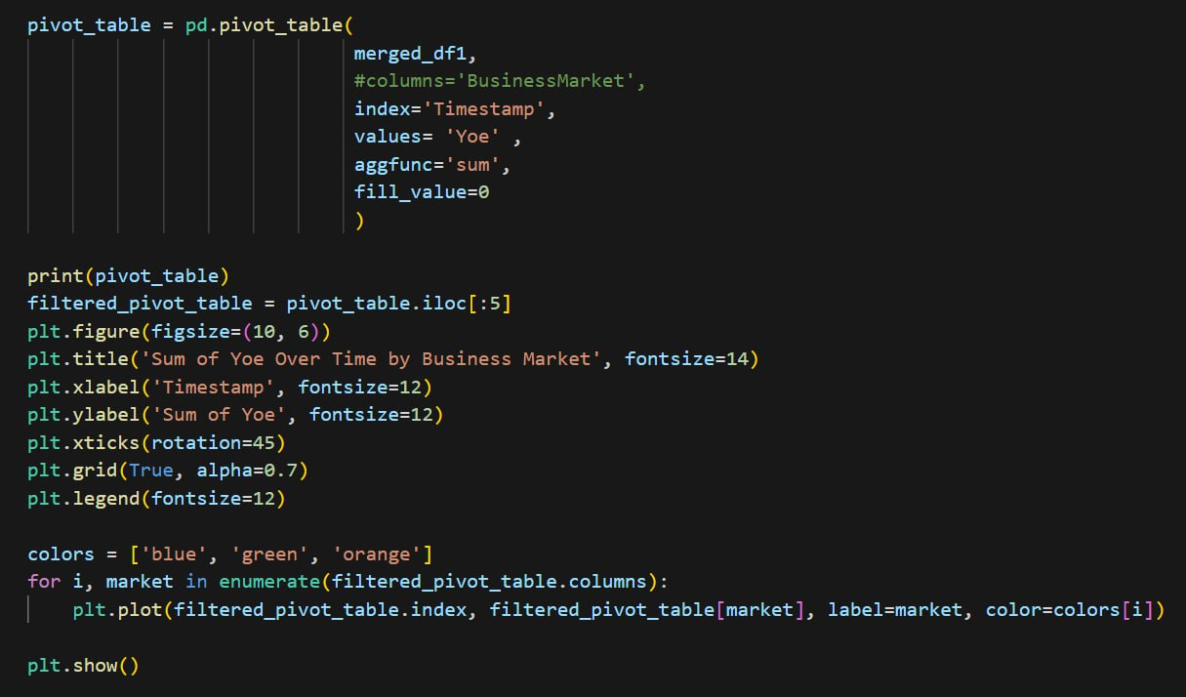

28-The code snippet filters the merged_df1 DataFrame to include only rows where the "Level" is "Senior", "Junior", "Mid-level", or "Manager", creates a pivot table using the "Level" column as index and the "MinCompensationRange" and "MaxCompensationRange" columns as values, calculates the mean of each value, fills missing values with 0, prints the pivot table, creates a bar plot with specified parameters, sets the title, x-label, y-label, rotation of x-ticks, adds a grid to the y-axis, and shows the plot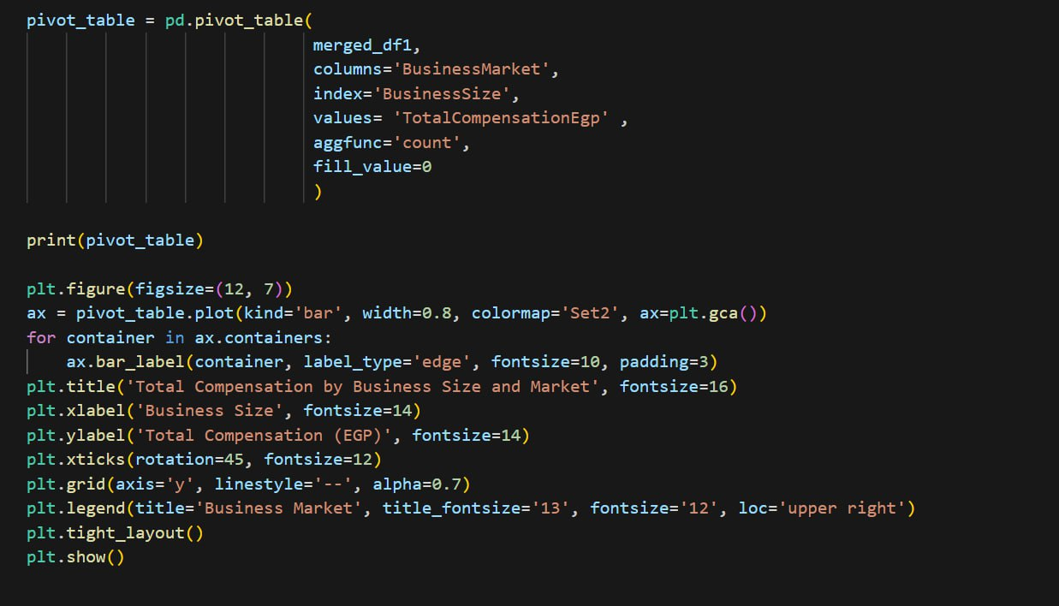

29-The code snippet creates a pivot table using the "BusinessFocus" column as index and the "BusinessMarket" column as columns, calculates the count of the "TotalCompensationEgp" column, fills missing values with 0, prints the pivot table, creates a bar plot with specified parameters, sets the title, x-label, y-label, rotation of x-ticks, legend, adds labels for the bars with the counts, adds a grid to the y-axis, and shows the plot.

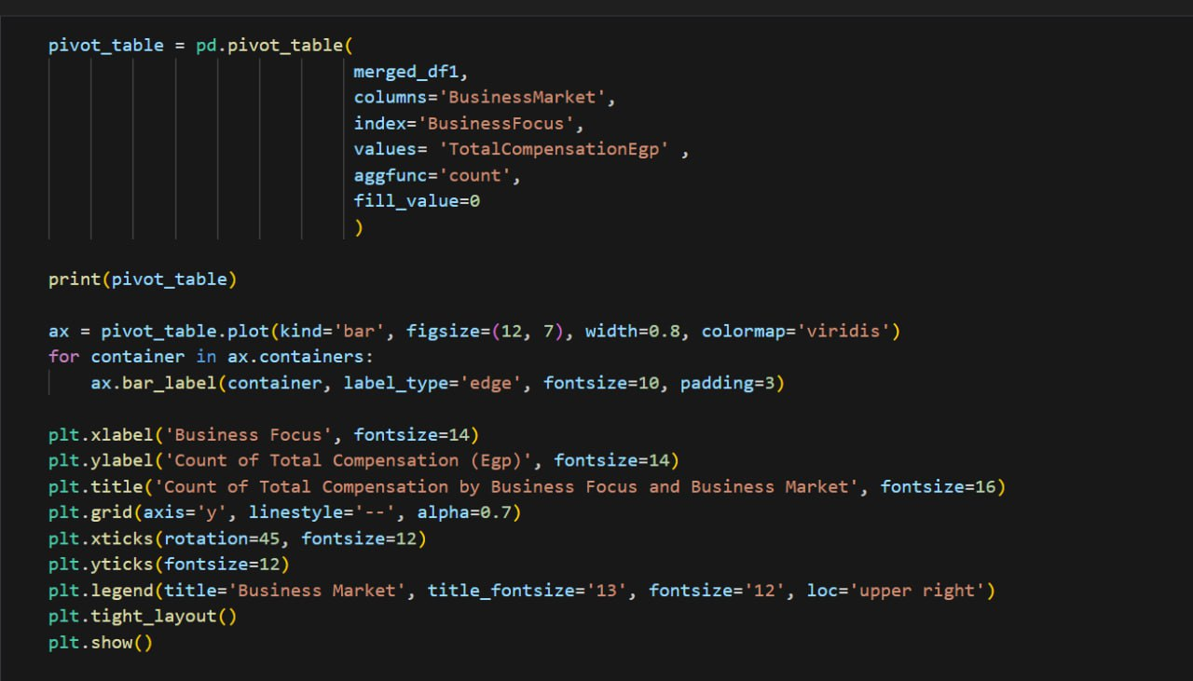

30-The code snippet creates a pivot table using the "BusinessFocus" column as index and the "BusinessLine" column as columns, calculates the count of the "TotalCompensationEgp" column, fills missing values with 0, prints the pivot table, creates a bar plot with specified parameters, sets the title, x-label, y-label, rotation of x-ticks, legend, adds labels for the bars with the counts, adds a grid to the y-axis, and shows the plot

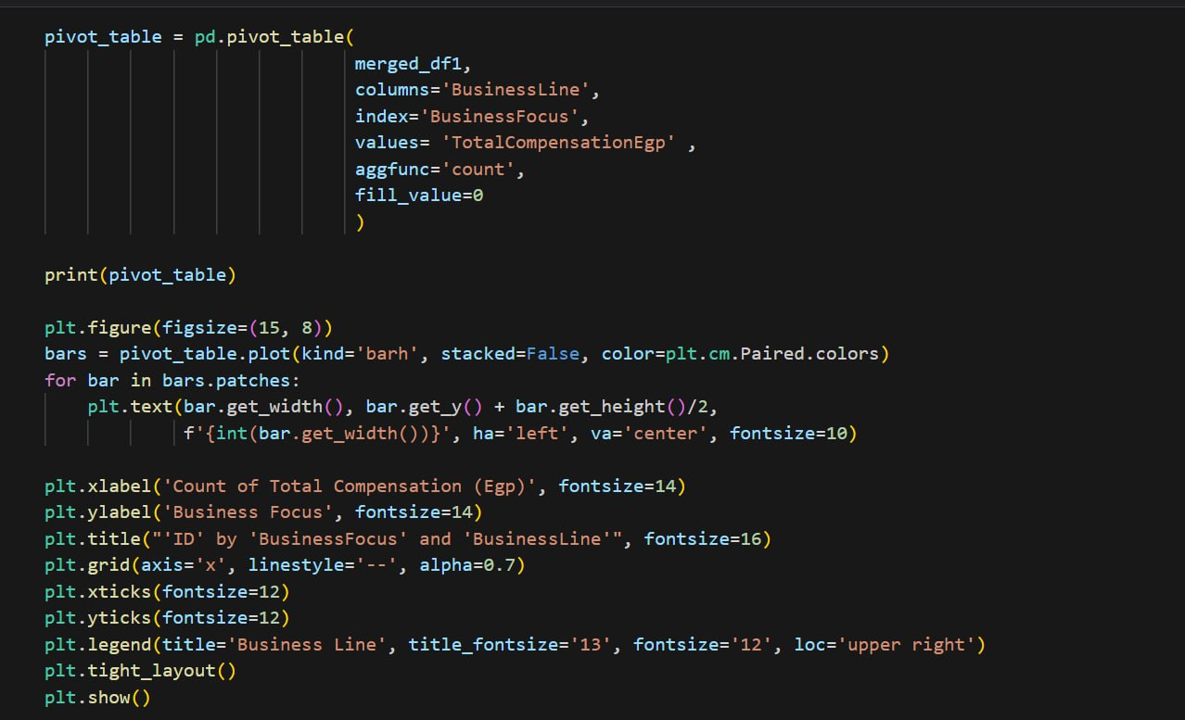

31-The code snippet creates a pivot table using the "BusinessSize" column as index and calculates the count of the "TotalCompensationEgp" column, fills missing values with 0, prints the pivot table, creates a bar plot with specified parameters, sets the title, x-label, y-label, rotation of x-ticks, adds labels for the bars with the counts, adds a grid to the y-axis, and shows the plot.

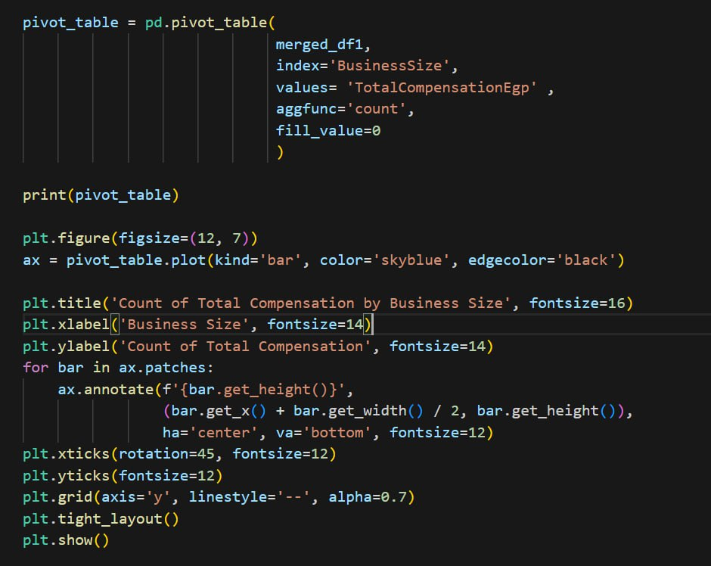

32-The code snippet filters the merged_df3 DataFrame to include only rows where the "Programming Languages" column contains one of the specified programming languages, creates a pivot table using the "Programming Languages" column as index and calculates the count of the "ID_PL" column, fills missing values with 0, prints the pivot table, creates a bar plot with specified parameters, sets the title, x-label, y-label, and shows the plot.

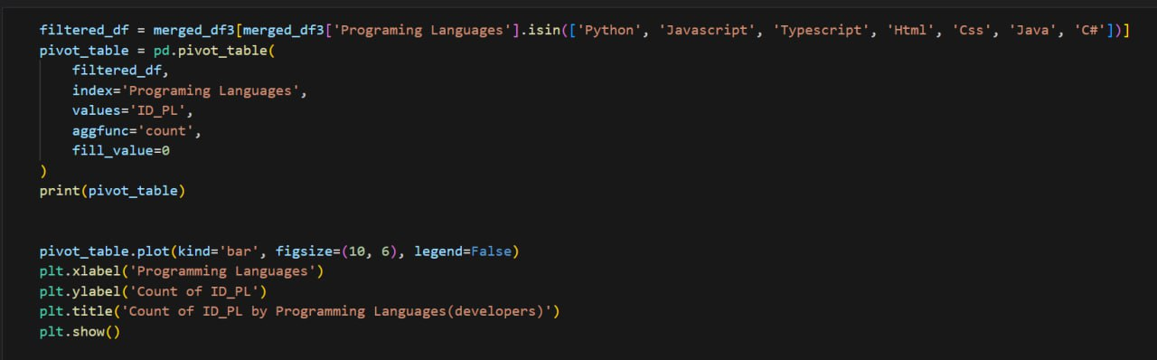

33-The code snippet filters the merged_df3 DataFrame to include only rows where the "Title" is "Full-stack Engineer", finds the top 6 programming languages used by these engineers, filters the DataFrame to include only these top 6 languages, creates a pivot table using the "Programming Languages" column as index and calculates the count of the "ID_PL" column, fills missing values with 0, prints the pivot table, creates a bar plot with specified parameters, sets the title, x-label, y-label, rotation of x-ticks, adds labels for the bars with the counts, adds a grid to the y-axis, and shows the plot.

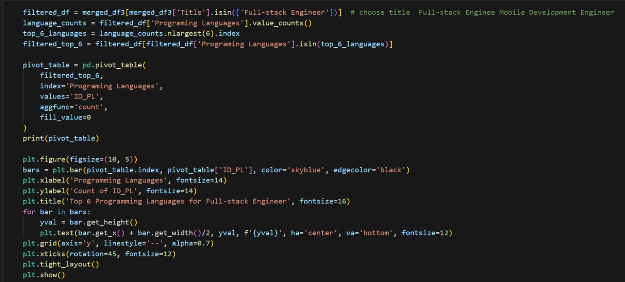

34-The code snippet filters the merged_df1 DataFrame to include only rows where the "Level" is "Senior", "Junior", "Mid-level", or "Manager", creates a pivot table using the "Level" column as index and the "MinCompensationRange" and "MaxCompensationRange" columns as values, calculates the mean of each value, fills missing values with 0, prints the pivot table, creates a bar plot with specified parameters, sets the title, x-label, y-label, rotation of x-ticks, adds a grid to the y-axis, and shows the plot

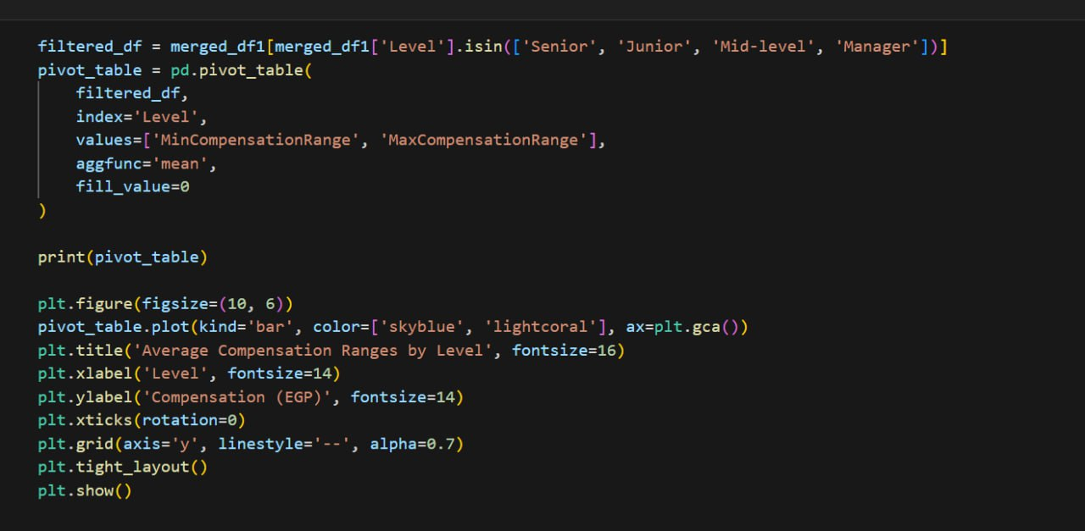

35-The code snippet creates a pivot table using the "Yoe" column as index and calculates the mean of the "TotalCompensationEgp" column, fills missing values with 0, prints the pivot table, creates a bar plot with specified parameters, sets the title, x-label, y-label, rotation of x-ticks, adds a grid to the y-axis, and shows the plot.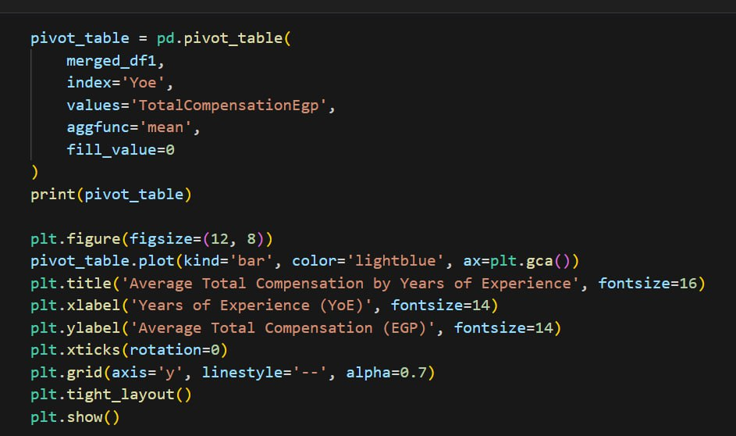

36-The code snippet creates a pivot table using the "WorkSetting" column as index and calculates the mean of the "TotalCompensationEgp" column, fills missing values with 0, prints the pivot table, creates a bar plot with specified parameters, sets the title, x-label, y-label, rotation of x-ticks, adds a grid to the y-axis, and shows the plot

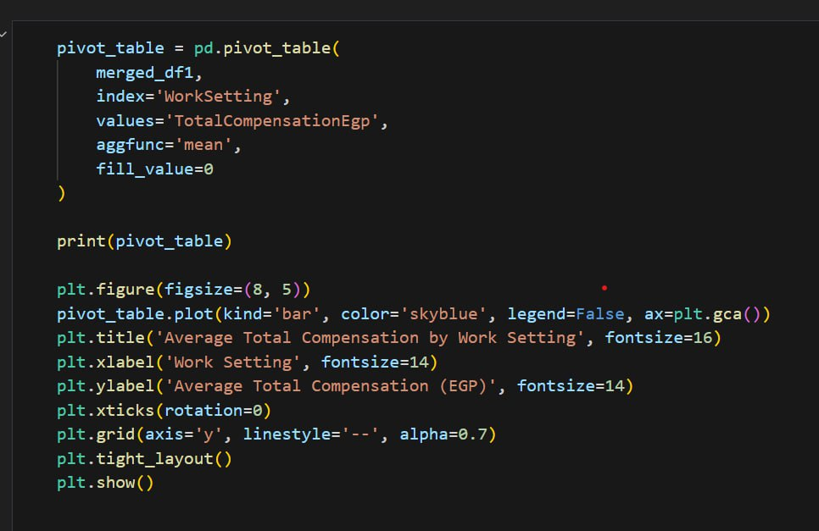

**Cleaning with Microsoft SQL Server**

1. **Show Duplicate Data**

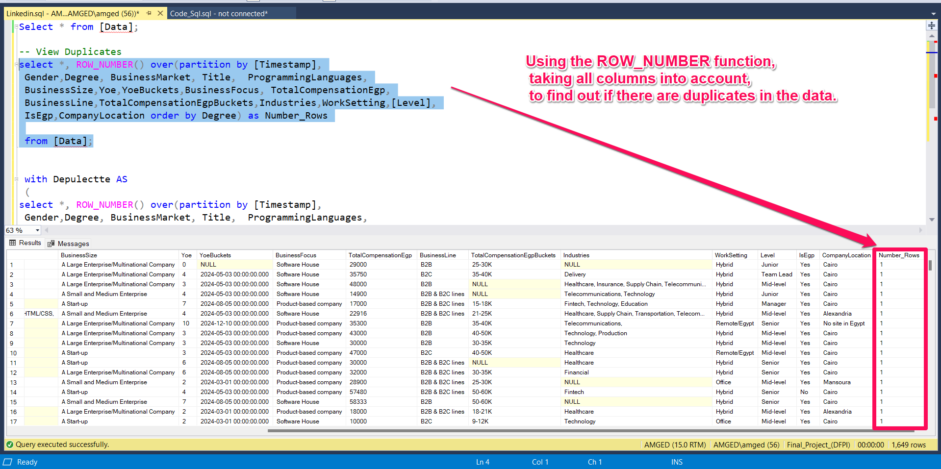

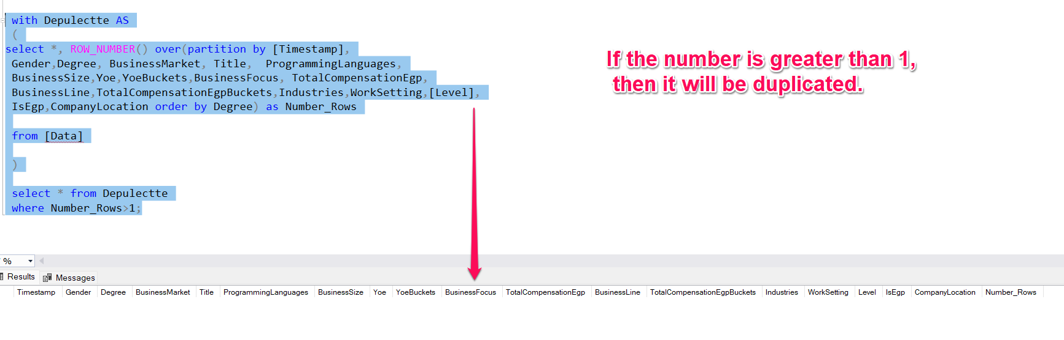

By using the ROW_NUMBER function to know if there is a duplicate in the data or not. After applying the query, there was no duplicate.

1. **Identify and display outliers**

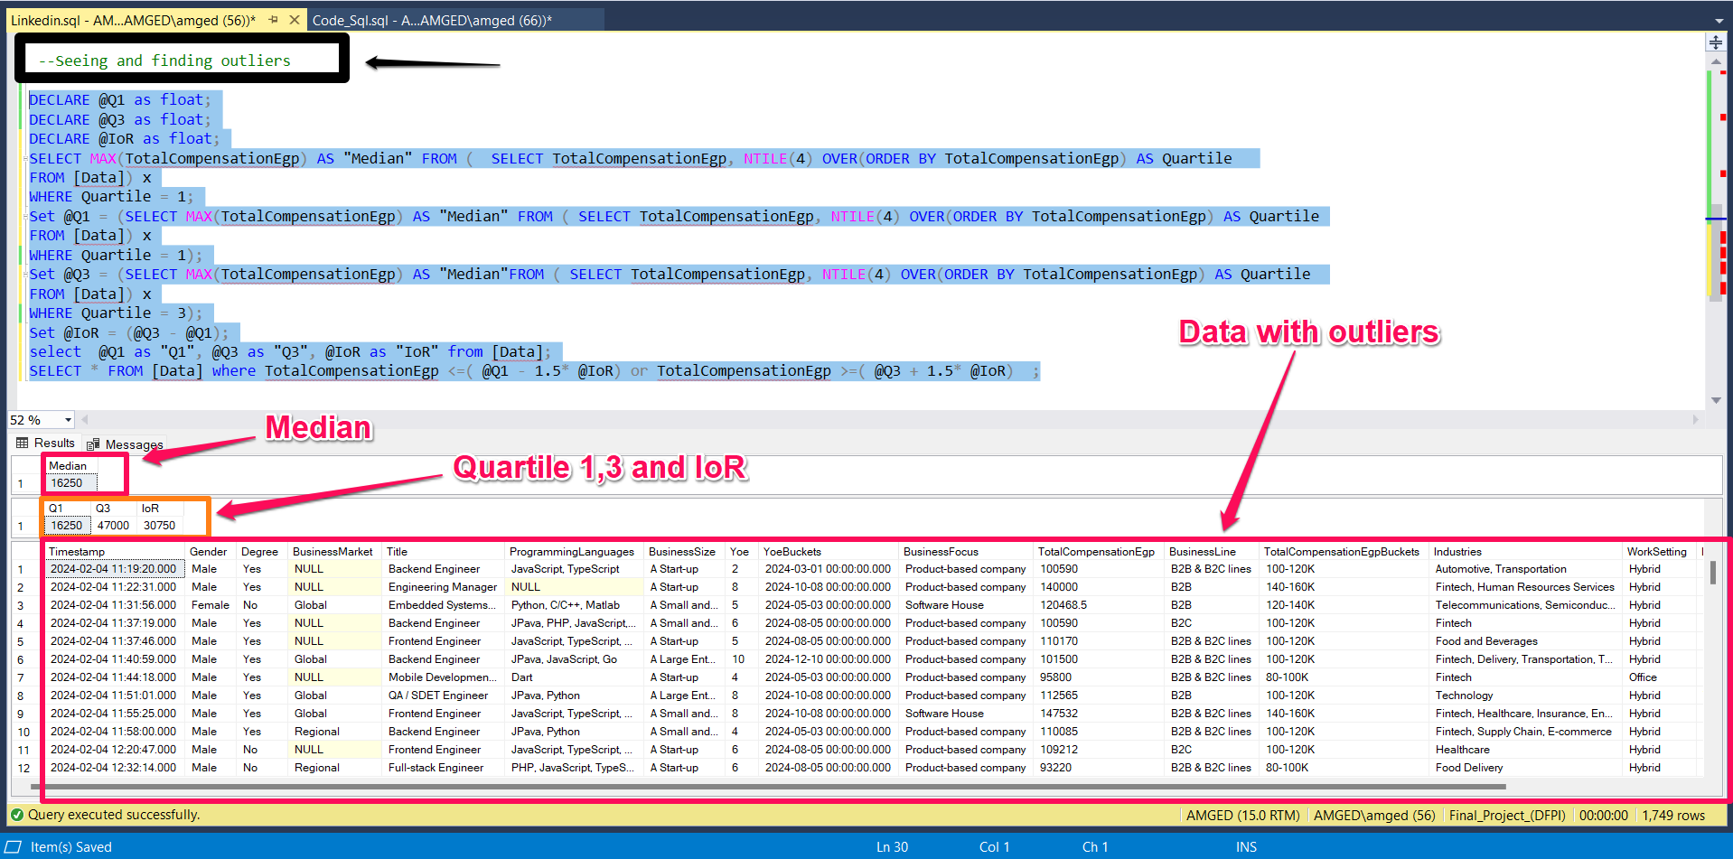

By calculating Median and Quartile 1, 3 and IQR I was able to identify and display outliers.

1. **Exploring Empty Values**

Explore data to find the number and percentage of blank values ​​for each column of the table.

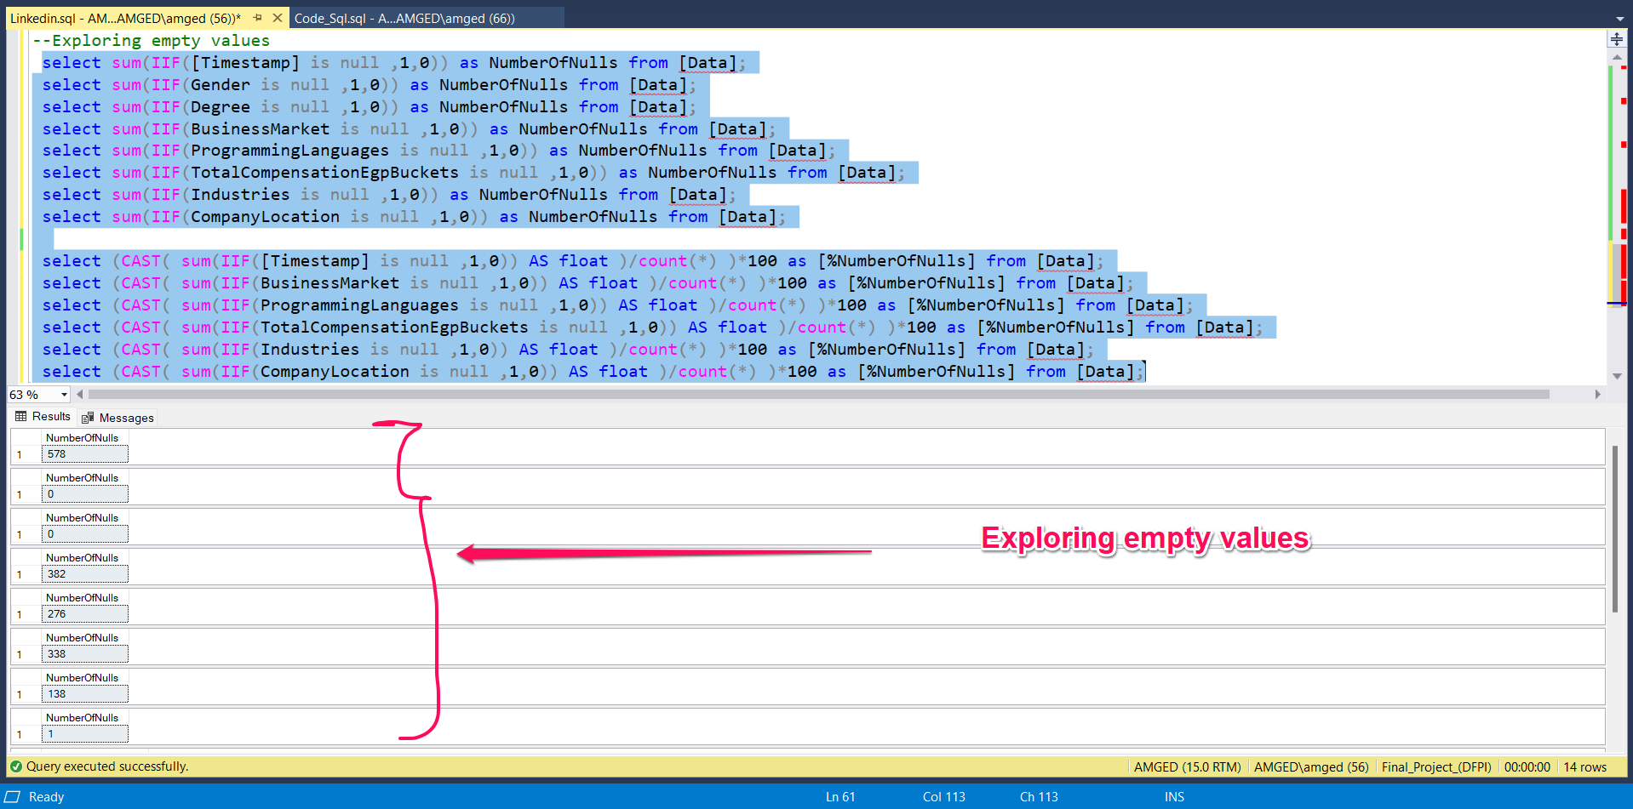

1. 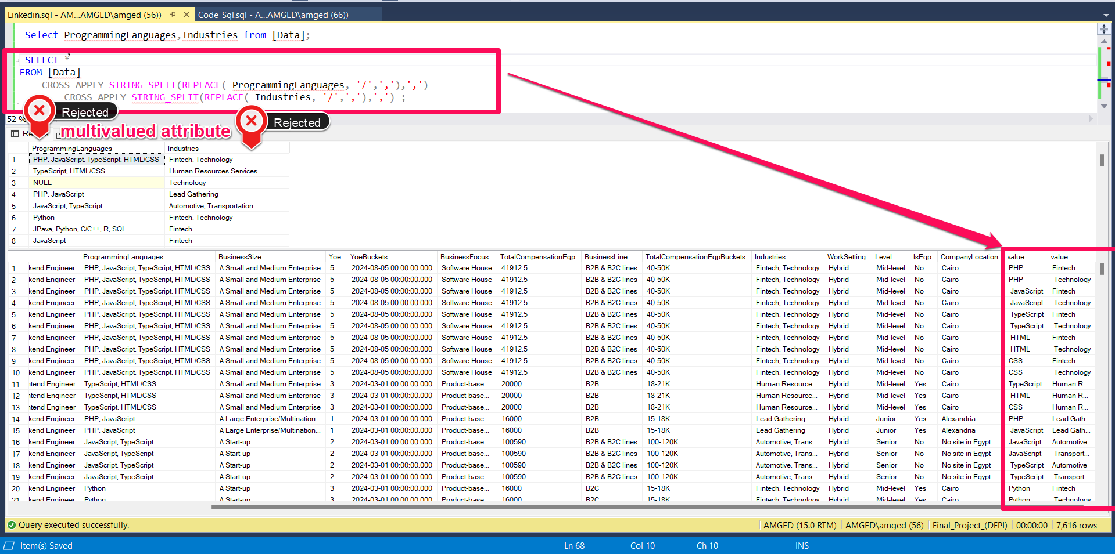 **Normalization (NF-1)**

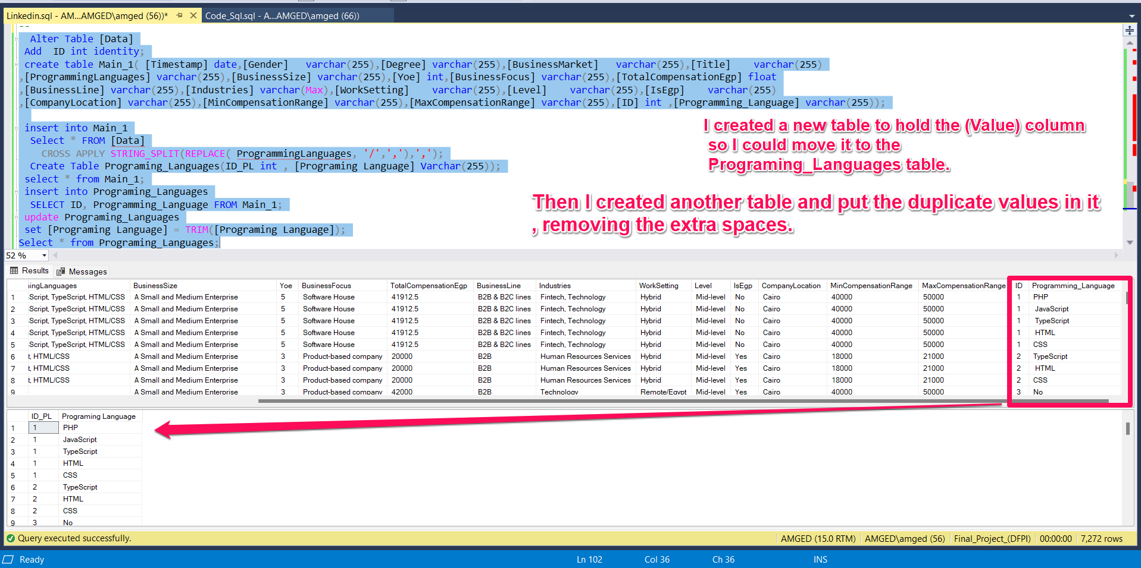

**Through Normalization, I solved the problem of multiple values.**

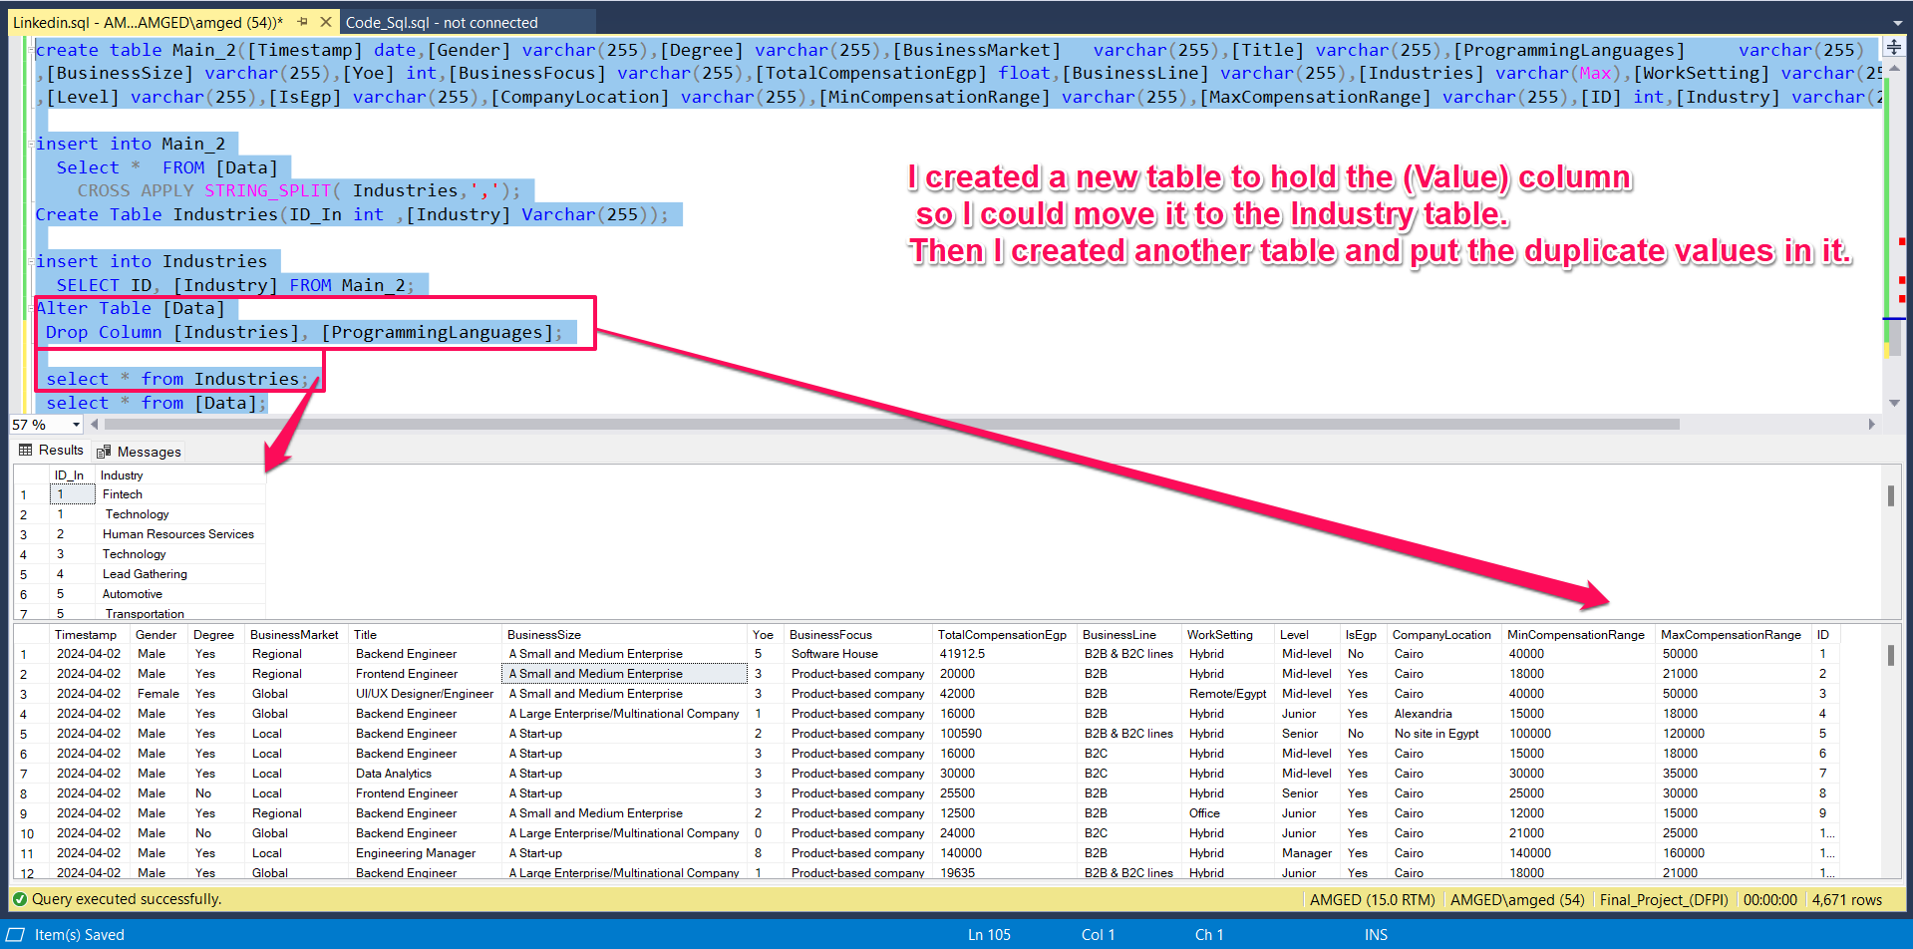

By creating a new table to solve the problem of multiple values ​​and linking them with a one-to-many relationship, there is no longer any benefit to columns containing multiple values.

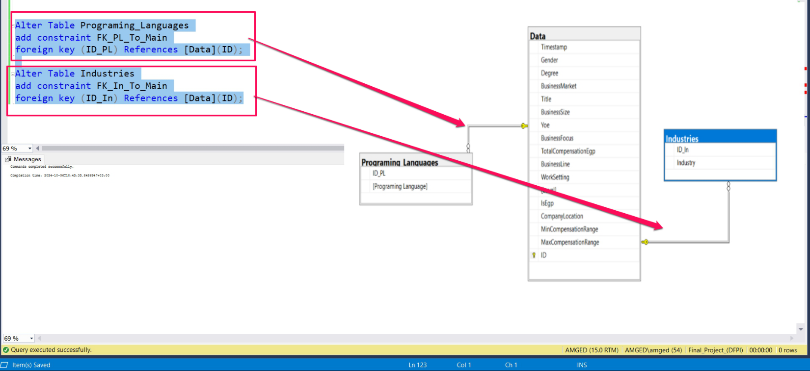

Repeat the same process on the industry column and create a new table for it and link them with a relationship.

1. **Normalization (NF-2)**

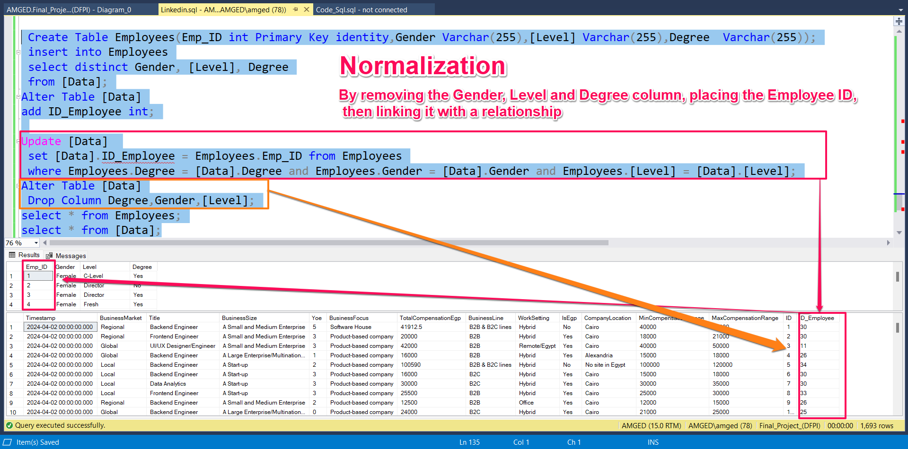

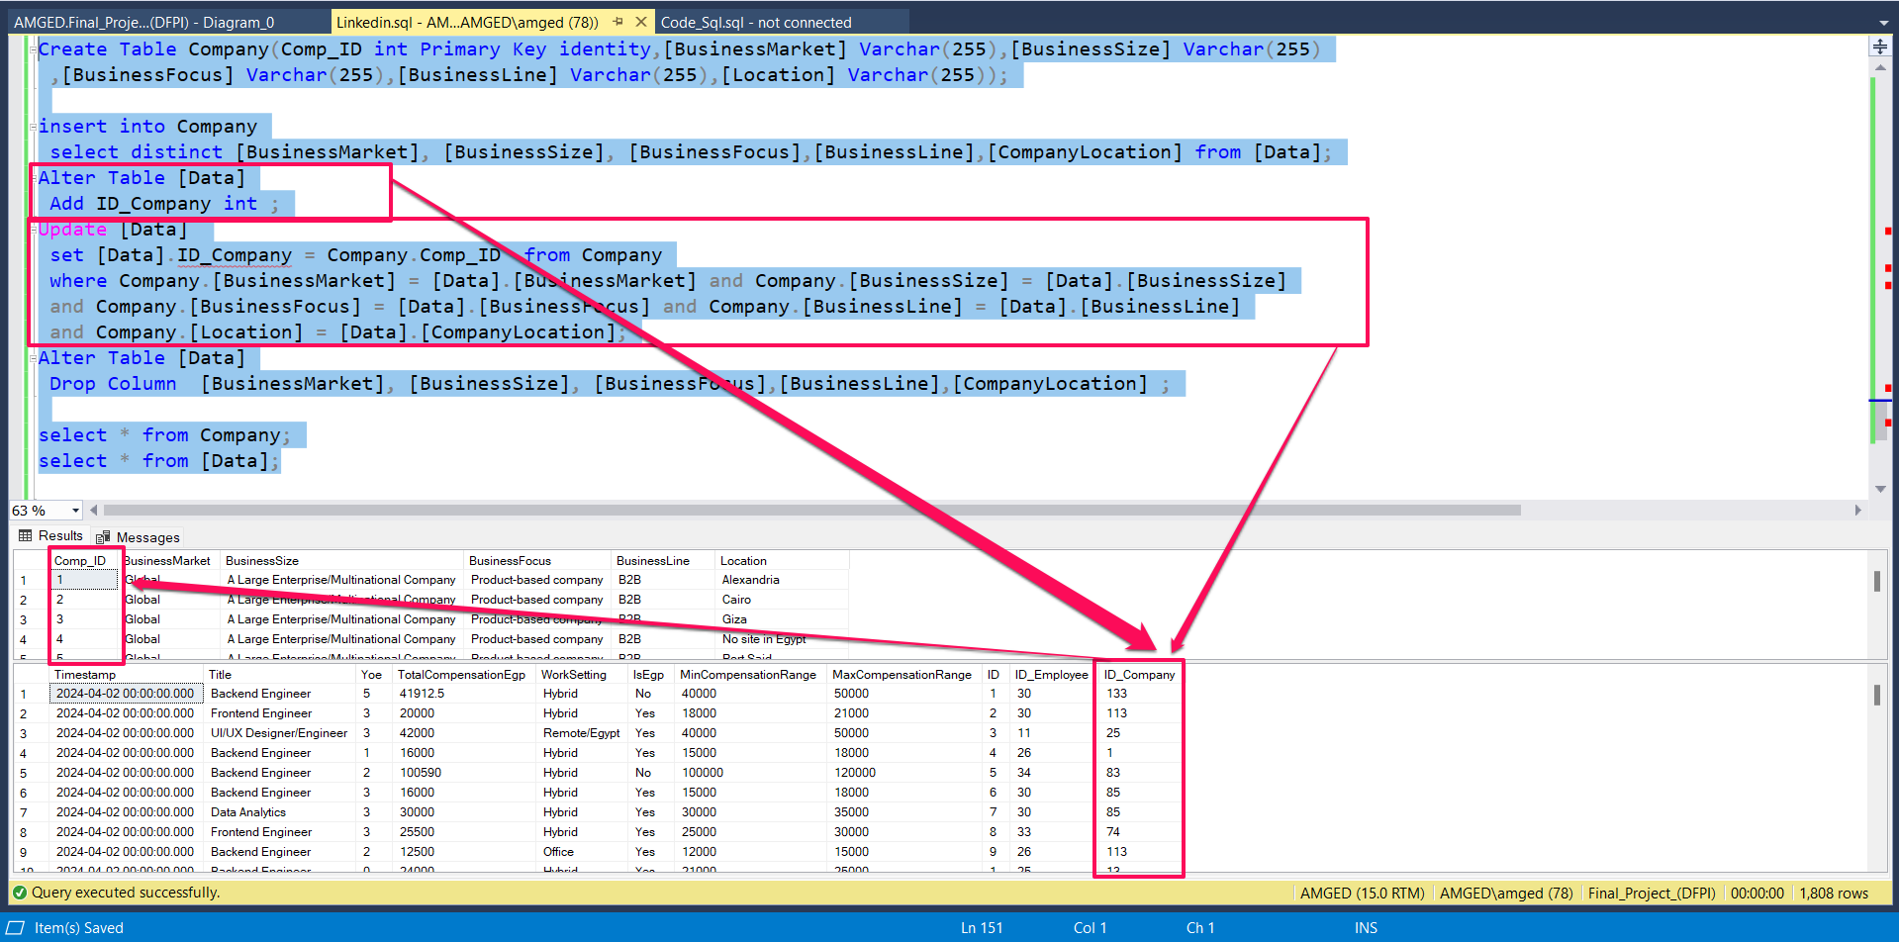

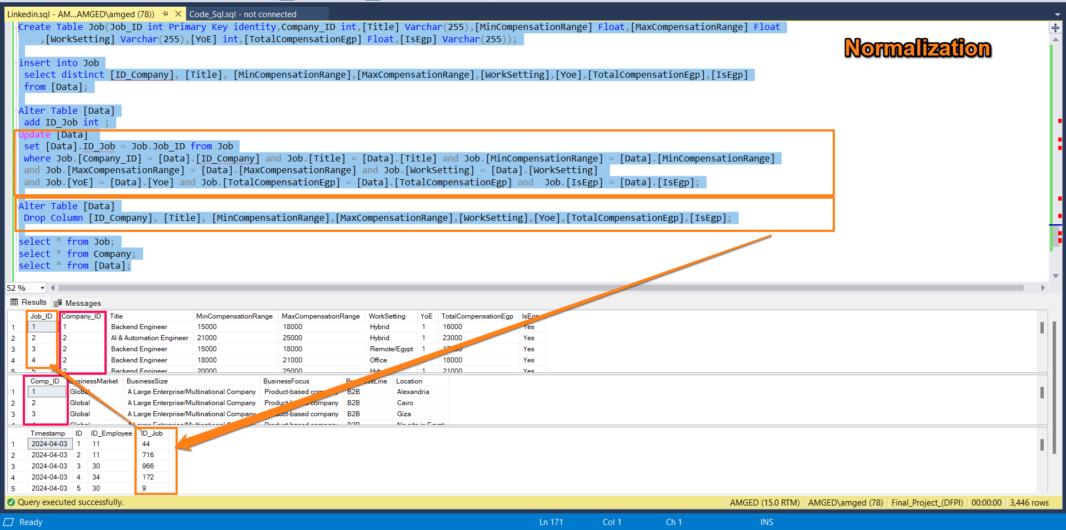

By creating new tables and linking them with relationships (Fact table and Dimension table) to organize the data.

1. **Create Calendar Table**

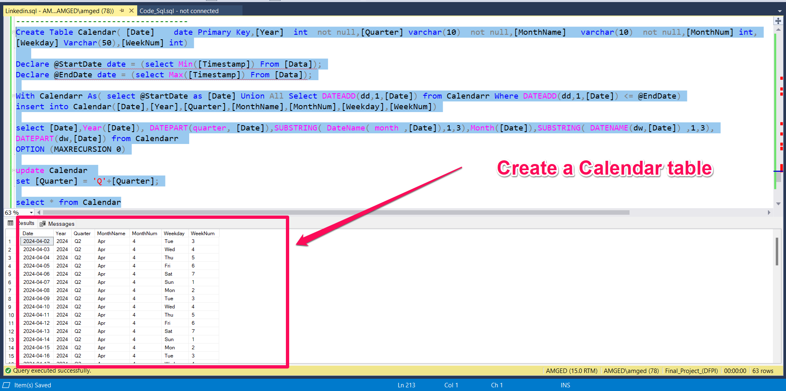

**Through it I can analyze better.**

1. **Linking Tables**

